Economizer and Mixing Section

Chapter Overview
Most recirculating air handling systems are equipped with an outdoor air intake to provide ventilation air to insure good indoor air quality in the occupied zones. The outdoor air intake can also slightly pressurize the building to reduce infiltration. In addition to bringing in outdoor air for indoor air quality and building pressurization, many recirculating air handling systems are equipped with an economizer that brings in outdoor air to meet cooling loads during mild conditions. The economizer and mixing section includes the outdoor air dampers, return air dampers, and mixing box as shown in Figure X.
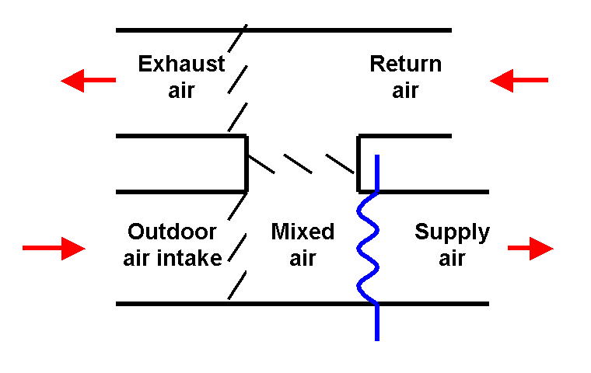
These components provide an important energy conservation function by allowing the system to mix return air with outdoor air to:
    - Eliminate or minimize mechanical cooling requirements when outdoor air conditions are suitable for free cooling.
- Eliminate or minimize preheat requirements for systems where minimum outdoor air flow rates are set above what would be required for ventilation purposes to positively pressurize the building envelope.
Figure 8.X Air-side economizer
To insure the overall success of the system in achieving its design intent, the minimum outdoor air regulation function must be integrated with these economizer functions.
Despite the significant energy savings that can be achieved by proper application of economizers, many economizer sections never achieve their design intent in the real world operating environment for a variety of reasons including:
    - Design issues
- Adjustment and commissioning issues
- System turndown issues
- System interaction issues
  - Operational issues
Thus, proper functional testing and adjustment of the economizer and mixed air section is essential to achieving design intent, efficient operation, and good indoor air quality for new systems. In a retrocommissioning environment, proper adjustment and functional testing of this section can yield significant operational improvements, indoor air quality improvements, and energy savings for an existing system.
While simple in concept, the successful operation of an economizer is dependent upon the dynamic interaction of a variety of components, all of which must be properly designed, installed, and adjusted. To properly design, install, and adjust a system with an economizer, it is first necessary to understand the operating theory and function of the process and the components used to accomplish it. The information in this chapter promotes successful economizer systems by providing technical information about the process and its components as well information about functional testing. As a result, the chapter is quite extensive.
To help use the information provided without being overwhelmed by it, the following navigational aids guide the reader to specific areas of interest.
    - A table of contents is included immediately following this section. You can also generate a table of contents in a separate frame to the left of this document frame by selecting “Format” then “Frames” then “Table of Contents in Frame”. Either table can be used to Navigate through the document. The table in the frame has the advantage of always being visible, but takes up some screen space. If you generate a table of contents in a separate frame and decide you don’t want it after all, then you can get rid of it by clicking inside the frame and then selecting “Format” then “Frames” then “Delete Frame”. Use the Table of Contents in the frame on the left to navigate.
- Click on the hypertext to be taken to the area of interest.
- Click on the Return to Overview Table of Contents hypertext at the end of each section to be brought back to Overview Table of Contents.
- Press the “Shift” key and the “F5” function key to return to the last cursor location. If you use a hyper link to jump from one area of the document to another, you can often (but not always, depending on how you scroll around once you are there) return to where you came from by using the “Shift F5” feature.
- Links, usually in the form of highlighted key words or a Chapter or Section Name, are also provided through out the chapter to take you directly from one section to a related section where appropriate. Page numbers are included if you are using a hard copy of this document instead of an electronic copy.
- Hyperlinks for related educational material are also embedded in the sample functional tests in Section 8.8.
- The task bar at the bottom of the screen has buttons for both the functional test and the document containing supporting information (as well as any other Word documents that you might have open). To return to the checklist, simply click on the button associated with it in the task bar at the bottom of your screen.
Overview Table of Contents, Chapter 8

8.1. Chapter Overview 1
8.2. Selecting the Right Combination of Tests 4
8.3. Common Economizer Problems 5
8.3.1. Economizer Evaluation Checklist 5
8.3.2. Nuisance freezestat trips 6
8.3.3. Transient Conditions 7
8.3.4. Coil Freeze-ups 8
8.3.4.1. No Freezestat Trip 9
8.3.4.2. Steam and Hot Water Coils Not Designed to Handle Subfreezing Air 10
8.3.4.3. Mixing, Damper Sizing and Damper Actuation Problems 10
8.4. Economizer Operating Theory 11
8.4.1. Minimum Outdoor Air Functions 14
8.4.2. Free Cooling Functions 17
8.4.3. Heat Recovery Functions 22
8.4.4. Mixing Functions 23
8.4.5. Building Pressure Control Functions 26
8.5. Control Strategies 27
8.5.1. Operating Control 28
8.5.2. Limit Control 29
8.5.3. Operational Interlocks 30
8.5.4. Safety Interlocks 33
8.5.4.1. Low Temperature Cut-outs 33
8.5.4.2. Static Pressure Switches 36
8.5.5. Ambient Condition Interlocks 36
8.5.6. Alarms 41
8.5.7. Smart Alarms 41
8.6. Components 42
8.6.1. Dampers 42
8.6.2. Actuators 46
8.6.2.1. Piston Actuators 47
8.6.2.2. Gear Train Actuators With Crank Arm Drives 48
8.6.2.3. Gear Train Actuators With Shaft Concentric Drives 49
8.6.2.4. Linear Actuators 49
8.6.2.5. Installation and Commissioning Issues 49
8.6.3. Sensing Elements 52
8.6.3.1. Temperature sensors 52
8.6.3.2. Freezestats 54
8.6.3.3. Enthalpy Switches and Sensors 55
8.6.3.4. Pressure sensors and switches 58
8.6.3.5. Pneumatic Pressure Transmitters 61
8.6.3.6. Electronic Force Based Differential Pressure Transmitters 65
8.6.3.7. Electronic Flow Based Differential Pressure Transmitters 65
8.6.3.8. Transmitter Installation and Sensing Line Considerations 66
8.6.3.9. Flow Sensors 70
8.6.4. Blank-off plates 72
8.6.5. Air Blenders and Baffle Plates 72
8.7. Verification Checks and CPTL References 74
8.8. Functional Tests 75
8.8.1. Actuator Stroke Test 78
8.8.2. Limit Switch Adjustment Test 79
8.8.3. Fan spin down test (see OA section) 80
8.8.4. Minimum Outdoor Air Flow Test 80
8.8.5. Building Pressurization Test 81
8.8.6. Outdoor Condition Interlock Test 82
8.8.7. Safety Interlock Test 82
8.8.8. Fan Operation Interlock Test 83
8.8.9. Permissive Interlocks Test 84
8.8.10. Temperature Traverse Test 84
8.8.11. Relative Calibration Test 85
8.8.12. Mixed Air Low Limit Test 92
8.8.13. High Turndown Ratio Test 92
8.8.14. Flow Linearity Test 93

Selecting the Right Combination of Tests
In new construction processes, economizer commissioning tests are targeted at insuring that the economizer system meets the design intent for the project, both on its own and in integrated operation with the rest of the air handling system. Design, installation, and adjustment problems that may not be detected without a good functional testing plan will often show up as future operating problems. Many of the functional tests included in this chapter can be used to identify potential operating problems and correct them before they occur. These same tests can be used in a retrocommissioning processes to define and correct existing operational issues. This section describes how to use this guide to target a functional testing plan on the issues that are the most significant for the systems and operating environment of a project, regardless of whether it is commissioning for new construction or retrocommissioning.
It is important to understand that not every test contained Chapter 8 will apply to every system. The time, effort and expense of some tests may not be justified by the configuration, operating environment or needs of the system. For example, the integrity of the mixing and the operation of the freezestat may not be important (or even required) on a 5,000 cfm packaged rooftop unit equipped with a factory economizer, direct expansion cooling, and a gas furnace located in a mild climate like San Francisco. In contrast, the same size unit, equipped with a field erected economizer and located in Minneapolis may require that attention be paid to the mixing functions of the economizer and the performance of the freezestat if equipment damage and nuisance freezestat trips are to be avoided.
In the general sense, test requirements should be tailored to the needs of the systems and project they will be used on, which is true for most commissioning processes. Budget, cost vs. benefit, and available time are additional factors that affect which tests are performed. To aid in evaluating these criteria for a project, the functional tests in the guide have two tables associated with them:
1 The Energy and Other Benefits Table lists the potential energy and resource savings and operational benefits that can be attributed to performing the test.
2 The Background Information Table includes information about the time and conditions required to do the test, precautions, instrumentation requirements, and acceptance criteria. This information can be weighted against the benefits to guide the user in determining if the test is appropriate for the project and system under consideration.
The educational information contained in the chapter will also be helpful in making this decision. A more detailed discussion of this topic can be found in Chapter 5 - General Functional Testing Information.
Return to Overview Table of Contents

Common Economizer Problems
It is not uncommon for economizer equipped systems that have run without difficulty for some time (often past the warranty year) to suddenly and surprisingly begin experiencing nuisance freezestat trips. To make matters worse, these systems are often very difficult to restart and return to normal operation after the trip.

Economizer Evaluation Checklist
The checklist that is linked to the button below uses some rules of thumb and quick evaluation techniques to help evaluate a new or existing system and determine:
Is the system likely to have economizer related operating problems?
- If so, what are the potential problems?
- Which functional tests should be targeted for implementation to help identify and correct these problems?

Click on the button to go to a checklist that will help assess the susceptibility of a new or existing economizer to operating problems. In addition to listing evaluation criteria, the checklist directs the user in appropriate follow-up actions and includes links back to appropriate sections of the Guide.
Link to Check List
EconEval

Click on the button to go to an abbreviated version of the checklist that contains all of the questions included in the preceding checklist but does not include all the guidance regarding how to address issues raised by the questions. This list provides a more compact “memory jogger” document for users who are familiar with the issues.
Link to Check List
EconEvalMemJog

There are several ways that this checklist can be used:
    - As a design review tool, the checklist can be used during the design phase to evaluate the economizer design information shown on the plans. Issues identified can be targeted for further review and evaluation by the design team.
- As a field tool for new construction, the checklist can be used in new construction during the construction observation phase to allow the installation to be evaluated as it is installed. Problems identified can be flagged and resolved prior to start-up and the functional test sequence can be structured to ensure successful resolution.
- As a field tool for retrocommissioning, the checklist can be used during the initial assessment phase of the project to help identify potential problem areas with energy conservation and performance improvement potential. The results can be used to target functional tests and identify solutions.
Return to Overview Table of Contents

Nuisance freezestat trips
Nuisance freezestat trips can be very difficult to troubleshoot because they often occur under very specific conditions that are difficult to duplicate or simulate. In many cases, the likelihood of such problems can be alleviated or nearly eliminated by the commissioning agent via a well-designed inspection and functional testing program focusing on the following areas.
    - Freezestat Location - Sometimes, system experience nuisance freezestat trips simply because the freezestat element has not been located properly. The purpose of the freezestat is to protect water coils that have not been designed to handle subfreezing air by shutting down the system if the air that reaches them is approaching freezing. The freezestat element should be at a location in the system that is never expected to see air near freezing temperatures under all normal operating conditions.
- Sensor Calibration - It is not uncommon for some freezestat problems to be traced to sensor calibration problems either directly with the mixed air sensor or freezestat or with the relative calibration of the other sensors in the system with reference to these sensors. The Relative Calibration Test included later in this chapter can be used to check new and existing systems for problems in this area.
- Poor Mixing - Poor mixing is also a common cause of nuisance freezestat trips. Section 8.4.4 Mixing Functions and Section 8.6.5 Air Blenders and Baffle Plates discuss key system parameters and design features that can help promote good mixing or correct poor mixing problems. The Temperature Traverse Test and Flow Linearity Test included in this chapter can both be used to pinpoint the sources of a poor mixing problem and identify its magnitude. The results of these tests can be used to target the appropriate solutions to the problem.
- Turn Down Ratio - The effects of a high turn down ratio can cause a system that exhibits good mixing characteristics at design flow rates to degrade to poor mixing performance at low flow rates. Variable air volume systems are particularly prone to this issue. Like most systems, VAV systems must function at full capacity on the warmest days of the year with all zones at full occupancy. But, the system also must function on the coldest day of the year with the majority of the zones unoccupied. As a result, VAV systems provide a wide variation in flow rate. It is not uncommon for systems with the ability to totally shut of flow to an unoccupied zone to see a flow variation of 10:1 or more (design flow vs. flow with one tenant area occupied at low load). Achieving these turn down ratios is key to maximizing the energy efficiency of the system since there is tremendous potential for saving fan, heating, and cooling energy by matching the system flow rate to the exact requirements of the load. However, it is not uncommon for the mixing problems created by this wide range of operating conditions to result in either the economizer cycle being defeated or the turn down capabilities being defeated. The High Turndown Ratio Test included in this chapter identifies the impacts of high turn down ratios on mixing performance and targets solutions.
- Control Sequence Problems - Many nuisance freezestat trips can be traced to control sequence problems. Sometimes, these problems are related directly to how the mixed air dampers are controlled during transient conditions, as is discussed in the next section of this chapter. In other instances, these problems are related to the integrated operation of the mixing section with the rest of the air handling system. These issues are discussed in Chapter 23 - Integrated Control Functions. The operating sequence of the preheat coil control system can also interact with the mixing section in a manner that causes nuisance freezestat trips. These issues are discussed in Chapter 10 - Preheat Section.
Return to Overview Table of Contents

Transient Conditions
Many nuisance freezestat trip problems can be traced to the inability of the system to respond to a transient condition. The most common transient condition that systems have to deal with is a system start-up. If the system controls the economizer dampers and coils in sequence based on a common sensor in the discharge of the unit, it is likely that the system will experience start-up problems during cold weather as is described under Limit Control in the Control Strategies section of this chapter.
Transient events that can trigger nuisance freezestat trips include:
1 Changes in the operating mode of a system from continuous operation to scheduled operation.
2 Changes in load profile that increases the turn-down ratio of a VAV system.
3 Climate extremes at or beyond design which were not encountered in the previous operating life of the system.
4 Changes in the performance characteristics of one or more of the heat transfer elements or other components of the system due to fouling, component wear or some other time and age related factor.
5 Unanticipated outages in a system that normally operates continuously due to a power outage in extreme weather.
Item 5 may not occur for years after the original start-up of the system, but when it does, recovery and restart can be extremely difficult for a variety of reasons including:
1 In many ways, a start-up is one of the most difficult and complex operational modes for an HVAC system. Every component and control loop in the system is subjected to a significant step change in its input (going from the shut down state to the operating state). These upsets result in the control loops modulating their outputs in an effort to find a stable control point in the new operating mode. Many of the control loops interact with each other. The unstable output of one control loop becomes an unstable input to the other, causing instability in the second control loop in the cascade.
2 If the system is not typically subjected to restarts because it operates continuously, then the system may not have been tuned so that it would reliably start and achieve stable operation in a reasonable time frame without excessive swings in its process parameters. Even if the system start-up was tuned during the commissioning process, the likelihood of a restart problem after an outage is much higher for a system that operates continuously than with a system that operates on a daily schedule. If a system runs continuously, the operating staff is comfortable operating it in that state and they are less familiar with the system’s transition from off to on.
3 Unscheduled outages are often associated with extreme climate conditions. A system that is knocked off line due to a power outage from an ice storm often must restart against extreme weather compared to what it normally encounters. The conditions aggravate normal start-up problems and can create some additional problems of their own. For instance, normal power may not be available and the facility may be running on emergency power. There have been instances where wiring errors during construction or renovation have resulted in interlock systems powered from normal power sources serving equipment that had its fans and DDC controllers powered by emergency power systems. When a power outage occurred, the fans and controllers resumed operation as soon as emergency power became available. But, the interlock circuits were inactive since there was no normal power and critical interlock functions failed to occur resulting in significant operating problems and damage to the systems.
Return to Overview Table of Contents

Coil Freeze-ups
Most coil freeze-ups can be attributed to one of three general causes:
1 Coils subjected to subfreezing air by design which either were not installed, connected and controlled properly to prevent their failure under a normal operating condition or for which the intended protecting mechanism failed.
2 Coils not designed or intended for subfreezing entering air temperatures which were subjected to them by the operation of a life safety control function (intentional or false trip).
3 Coils not designed or intended for subfreezing entering air temperatures which were subjected to this condition due to failure of a preheat system or failure of a control or limit system.
Failures in the first two categories are discussed in Chapter 10 - Preheat Section and in Chapter 22 - Smoke Control Systems respectively because the issues that tend to be the cause of the problem are discussed in more detail there. Failures in the third category usually relate to malfunctions in the economizer system. In most cases, there is a direct and an indirect cause.
    - The direct cause is typically that the freezestat failed to function and did not provided the intended freeze protection.
  - The indirect cause is a malfunction upstream of the freezestat that caused the coil to be subjected to subfreezing air.
There are some rare situations where the direct cause of the coil failure is not a freezestat failure. This situation is discussed in more detail later in this chapter under Control Strategies - Safety Interlocks.
The following sections discuss common coil freeze-up issues.
Return to Overview Table of Contents

No Freezestat Trip
There are instances where a coil has frozen and the freezestat never tripped. This can occur for a number of reasons.
1 Freezestat Mechanism Failure - Freezestats can fail for a variety of reasons including failures within the switching mechanism as well as a failure of the sensing element. Since the sensing elements generally rely on the change of state of a refrigerant charge that is contained in them, damage to the element can cause a loss of the charge and render the device inoperable. The damage may or may not be visually obvious. For this reason, a functional test that targets the entire mechanism, including the sensor, is a better test than one that targets just the electrical switching mechanism. An example of such a test is included in the Safety Interlock Test later in this chapter.
2 Freezestat Disabled - If the economizer has not undergone a thorough commissioning process that ensured that the economizer functioned reliably, then the economizer may plague the operators with nuisance problems, particularly, the start-up problems associated with a lack of a mixed air low limit control sequence. In frustration, the operators may have disabled the freezestat by wiring it out of the circuit or installing a jumper across its terminals. Unfortunately, this approach cures the symptom, not the problem, and while the solution may not immediately cause a coil freeze-up, it places the system at risk. In most cases, the coil will eventually freeze unless the true cause of the problem is identified and corrected.
Return to Overview Table of Contents

Steam and Hot Water Coils Not Designed to Handle Subfreezing Air
Contrary to popular opinion, steam coils that have not specifically been designed to handle subfreezing air can freeze, especially at low steam flow rates. At low steam flow rates, the steam condenses to a liquid at some point early in the tube circuit. It then must flow as condensate (liquid water) to the end of the tube and out of the coil. If the air is subfreezing, the coil is often capable of cooling the condensate to the freezing point before it exits the coil, eventually rupturing the tube.
Steam coils and water coils that are subjected to subfreezing temperatures by design need to be designed, installed and controlled in a manner that will allow them to function without freezing. This is discussed in greater detail in Chapter 10 - Preheat Section. Steam coils that are not designed to handle subfreezing air need to be protected by a freezestat, just like any other water coil.
Return to Overview Table of Contents

Mixing, Damper Sizing and Damper Actuation Problems
Dampers that are not properly sized or actuated can cause control linearity and mixing problems. Damper pressure drop relative to the system pressure drop has a major impact on achieving a linear relationship between damper flow rate and damper stroke. The linkage arrangement used to connect the actuators to the dampers can also have an impact on achieving this linear relationship. The configuration of the mixing plenum and the damper sections play important roles in ensuring the outdoor air and return air streams are thoroughly mixed by the economizer process. If these issues have not been addressed by the design, installation, and commissioning process, then the resulting poor damper performance can lead to coil freeze-ups.
Economizers with poor linearity and mixing problems can have excessively stratified air streams. In one instance in a retrocommissioning environment, performing the Temperature Traverse Test revealed a temperature difference of 60°F across the plenum with nearly the subfreezing outdoor air temperature in one layer at the bottom of the plenum and nearly the return air temperature in a layer at the top. The freezestat element was located in a manner that did not expose it to the layer that was subfreezing. The averaging sensor controlling the economizer was doing what it was designed to do (averaging the temperature across its element) and indicated a mixed condition of 53°F since it was not exposed to the warmest or coldest layers. As a result the economizer control loop thought it was doing a fine job, the freezestat sensed that nothing was wrong, and the coil froze several of the bottom rows where the subfreezing air in the bottom layer contacted it. VAV systems require special attention in this regard as was discussed in this chapter under 8.5.1 Operating Control and under 8.3.2 Nuisance Freezestat Trips.
Return to Overview Table of Contents

Economizer Operating Theory
The design, performance, and operation of the economizer cycle are directly related to the overall make-up and exhaust flow pattern for the system. Thus it is necessary to consider the economizer cycle in the context of the requirements for outdoor airflow and exhaust airflow.
Most recirculating air handling systems bring in a volume of outdoor air typically referred to as the minimum outdoor air requirement. This volume is established based on the occupancy of the area served and the processes it contains. Generally, the minimum outside air is intended to provide ventilation to ensure satisfactory indoor air quality (IAQ) and make up for any exhaust that is taken from the space by process functions like a lab exhaust hood.
The minimum outdoor air requirement often includes an additional component to provide for building pressurization. Since it is a practical impossibility to construct a 100% air tight building envelope, there will be air leakage to or from most buildings. The amount of leakage and where it occurs will be influenced by:
    - The nature of the building envelope design.
- The materials and quality of construction of the building envelope.
- The interactions and operating status of the air handling equipment in the building.
- The wind pressures acting on various faces of the building.
- The traffic flow through the building entrances and exits.
  - The stack effect or chimney effect.
Pressurizing the building tends to cause air to exfiltrate through the leaks and openings in the building envelope rather than infiltrate through them. This is important for several reasons. For one thing, occupants in perimeter spaces and in spaces that interface directly with the building exterior, like the lobby, will be much more comfortable if conditioned air from inside the building moves past them to the building exterior rather than having unconditioned air from the exterior of the building move past them into the building. This is especially true during extreme winter weather. In addition, pressurizing the building ensures that all air entering the building is positively conditioned. This has several important implications:
1 During the summer, the potential for condensation in the building envelope is minimized since all of the air inside the building will have been cooled and dehumidified. If hot, humid air is allowed to infiltrate through the building envelope, then it is quite likely that moisture will be condensed out of the humid air when it comes in contact with air or surfaces inside the building that have been cooled below its dew point. At a minimum, this can cause damage to finishes and materials. Frequently this situation will lead to mold growth and IAQ problems.
2 During the winter, air that infiltrates will most likely be picked up as a load by the perimeter system. In most cases, the load on the perimeter system is offset by energy from a boiler or other heat generating device. On the other hand, proper control and adjustment of the economizer cycle will allow pressurization of the building and exfiltration through openings and leaks in the building envelope. In effect, the building pressurization allows recovered energy from internal gains to be used to offset the heating load associated with conditioning this air. This will be discussed in greater detail in Section 8.4.5 Building Pressure Control Functions.
Thus far, out discussion has focused on outdoor air that is introduced into a building for purposes other than an economizer cycle, minimum outside air and building pressurization. Many air handling systems that serve cooling loads are equipped with an economizer cycle to save mechanical cooling energy. This cycle functions by bringing in extra outside air, above and beyond what is required for ventilation purposes, and mixing it with return air to provide the supply temperature required for cooling. The extra outside air is brought in instead of running refrigeration equipment to cool the mix of return air and minimum outdoor air. The outdoor air volume will modulate from the minimum outdoor air position when the outdoor air temperatures are significantly below the required supply temperature towards the 100% outdoor air position as the outdoor air temperature approaches the required supply temperature. When outdoor air temperature (or enthalpy) is too high for cooling, the outdoor air damper should be at the minimum setting for ventilation. Ideally, the return air volume will be proportionally decreased as the outdoor air volume is increased so that the total volume delivered by the system remains constant.
To summarize the preceding discussion, the outdoor air that comes into a building generally falls into three categories:
    - Air that is brought in for ventilation/IAQ control and make up air.
- Air that is brought in to pressurize the building and control infiltration.
  - Air that is brought in by the economizer cycle for free cooling.
If outdoor air was simply introduced into the building without regard for how it would be removed, then there would be a tendency for the supply fan system to pressurize the building. Eventually, the pressure in the building would become so high that the doors would be blown open and/or the flow of outdoor air into the building would be restricted. While these problems seem obvious, they are often not addressed by the design documents or are misinterpreted in the field resulting in commissioning and operational problems. Problems with bringing in outdoor air fall into the following categories:
    - Pressure relationship problems between various spaces in the building.
- Building pressurization problems.
  - Temperature control problems when operating in the economizer mode.
Generally, the minimum outdoor air quantity brought into the building is removed from the building by the toilet exhaust system and other exhaust processes. It is also common to provide for some building pressurization by:
    - Increasing the minimum outdoor airflow rate as necessary to provide the desired level of pressurization.
  - Reducing the amount of air positively removed from the building by the toilet exhaust and other exhaust systems to provide the desired level of pressurization.
The additional outdoor air that is brought in by the economizer cycle for temperature control purposes is generally removed from the building by some sort of relief system. Generally, this will be accomplished via one of the following methods.
    - A barometric damper system.
- A modulating damper system controlled directly by the same signal as the economizer damper system (the outdoor air and return air dampers).
  - A modulating damper system controlled by some other signal such as building static pressure.
For systems equipped with return fans, the relief system is usually downstream of the return fan location. On systems not equipped with return fans, there may be relief fans if the pressure drop through the relief system with the economizer on 100% outdoor air is greater than the desired positive pressure in the building. A more detailed discussion of the various relief options can be found in Section 5.17 - Return, Relief and Exhaust Systems.
The following subsections give more detail on the five main functions of the economizer operation:
1 Minimum outdoor air
2 Free cooling
3 Heat recovery from return air
4 Mixing outside and return air
5 Building pressure control
Return to Overview Table of Contents

Minimum Outdoor Air Functions
As stated previously, minimum outdoor airflow must be introduced in most air handling systems to ensure good IAQ and to pressurize the building. In general, this flow rate should match or exceed the amount of exhaust taken from the area served by the system unless the area served is required to operate at a negative pressure relationship relative to the surrounding areas. Even then, this mismatch between outdoor air and exhaust must be made up by the system from which the air is “stolen” if the building is to remain at a net neutral or positive relationship with the outdoors. In most cases, operating a building at a negative pressure relationship relative to the outdoors is undesirable and will result in problems that can include:
- Poor occupant comfort due to drafts and infiltration.
IAQ and building envelope problems due to condensation.
These problems are generally due to the infiltration of unconditioned, untreated outdoor air into the building envelope and occupied space via cracks and leaks. In a building that is neutral or slightly positive with regard to the atmosphere, the air required to match the exhaust flow from the building and pressurize it is brought in through the air handling equipment and treated to heat, cool, and dehumidify it. The air is introduced into the occupied zones in a manner that will enhance occupant comfort rather than detract from it (assuming everything else is working right). Then the air can be exhausted from the building and/or allowed exfiltrate out through the cracks and leaks with very little potential for damage to the envelope or discomfort to the occupants.
Obviously, the design, set-up and operation of the systems that provide the minimum outdoor air flow are critical to achieving the design performance of most air handling systems. There are a variety of approaches that can be used to provide minimum outside airflow, sometimes with varying degrees of success. They typically will fall into one of the following categories.
- Provide a Limit Signal that Allows the Economizer Dampers to Provide the Minimum Outdoor Air - In this arrangement, the minimum outdoor airflow is often neglected or is set based on a percentage of the output signal. For instance, if the system is designed for 20% minimum outdoor air, then a minimum position signal equal to 20% of the actuator span is sent to the economizer dampers. This assumes a linear relationship between actuator stroke and airflow, which is often a bad assumption, especially if the dampers are oversized. The two most likely issues are:
1 The minimum flow may be much higher than required because of the non-linear relationship between flow and damper stroke. Review the damper sizing curves depicted in Figure ? later in this chapter to gain some insight into this issue. A high minimum flow wastes energy due to treating excessive quantities of outdoor air.
2 The minimum flow is not positively set (the amount of outside air is not regulated). Older or lower quality dampers may still provide 5-10% minimum outdoor air when they are closed due to leakage, but newer, low leakage dampers may not be counted on to provide this. Without adequate minimum outdoor airflow, the building can experience indoor air quality problems (IAQ) and/or problems with pressure relationships.
The limit signal approach can be made to work for constant volume systems where the economizer dampers have been properly sized and the pressure relationships tend to remain fixed. The approach may not provide the required flow under all operating conditions in systems where the pressure and flow relationships vary with load, like a VAV system. As the load decreases, typically less outdoor air is brought into the system as the VAV system turns down. If the load change is not proportional to the occupancy change, then inadequate minimum outside air may result. In any case, it is critical that the system be set up to provide the required minimum outdoor air flow rate and then maintained in a manner that ensures this. The commissioning process can pay a key role by:
1 Functionally testing and coordinating with the balancer at start-up to ensure proper minimum outdoor air flow rates and building pressure relationships.
2 Training the operating staff to help them understand the initial settings and ensure their persistence.
3 Document the initial settings as well as the procedure used to obtain them, thereby further ensuring their persistence.
- Provide an Independent Non-Regulated Minimum Outdoor Air Damper - This approach is an improvement over the first approach because an independent damper dedicated to the minimum outdoor air function can provide more reliable outside air regulation. Typically the damper is interlocked to open when the unit is in operation and in an occupied cycle and closed when the unit is shut down.
Achieving the desired flow rate involves an effort on the part of the start-up team to measure and adjust the system to meet the design requirements. Sometimes, an independent manual balancing damper is provided in series with the automatic damper so that it can be used to set the flow while the automatic damper provides the on/off function. In other instances, the required flow is achieved by adjusting the manual damper’s crank radius or limiting its travel so that it only opens to the point required to deliver the design minimum outdoor air flow.
Because this design does not measure and regulate for a specific flow rate it is still subject to the same problems as the first approach on systems where the pressure and flow relationships vary with the load. As with the first case, a good commissioning process is a key step in achieving and maintaining design operation.
- Provide an Independent Regulated Minimum Outdoor Air Damper - This approach adds flow measurement and control to the independent non-regulated minimum outdoor air approach discussed previously. In some applications, a dedicated minimum outdoor air fan is also provided. When properly implemented and commissioned, this design provides one of the most effective ways to:
1 Ensure that the required minimum outdoor air flow rate is delivered under all operating conditions.
2 Allow the minimum outdoor air flow rate to be adjusted to match current occupancy levels.
The set point can be a fixed value set for the design minimum flow rate or can be a variable based on occupancy, CO₂ level or some other parameter. The commissioning issues are similar to the previous options discussed, but have the added complication of a flow control loop. The commissioning agent should take steps to ensure that the control loop is properly set up and tuned and that the input signal it is receiving accurately represents the actual flow rate. These checks often require attention during the design and construction phase to the inlet conditions at the flow sensor to ensure a good velocity profile.
  - Provide an Independent Make Up Air Handling System that Treats all of the Make Up Air for the Building and Supplies it to Recirculating Air Handling Systems - This approach is frequently seen in systems like clean rooms where pressure relationships and cleanliness requirements make an airside economizer cycle difficult and/or cost prohibitive (due to filtration requirements) to implement. Make-up air handling systems are also emerging as a viable process in locations where a wet economizer cycle can provide the benefits of free cooling without the complexity of an airside economizer cycle. Under this approach, an independent, relatively high-quality air handling system conditions the entire make up air quantity for a building or portion of a building. This air is then distributed to recirculating type air handling systems, which mix the make-up air with the recirculation stream and deliver it to the occupied space. Figure ? illustrates a typical clean room application of this concept.
The commissioning issues are the same as previously discussed; the outdoor air flow needs to be set correctly, and, if the recirculating system operates with variable flows and pressures, then it may be necessary to regulate the make-up air connection.
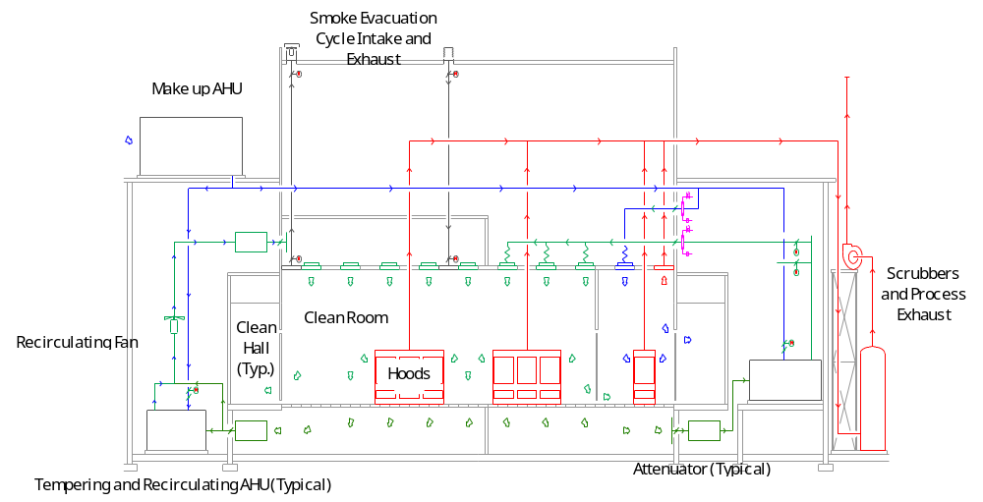
Figure ? - Typical clean room application with recirculating air handling systems that have their minimum outdoor air requirements supplied from an independent make up air handling unit. The dark blue lines represent make-up air. The green lines represent return air. The teal lines represent recirculated supply air to the clean room, which is a mix of the make up air and the return air from the space. The red lines represent exhaust from the space. If the recirculating units were equipped with economizer cycles, it would be very difficult to control the pressure relationships between the various parts of the clean room and the clean corridor. These relationships are critical to controlling contamination in the clean room. Filtration costs could also become prohibitive if given the large volumes of air that are recirculated and the level of cleanliness that is required.
Ultimately, the control of minimum outside air needs to be integrated with the economizer functions discussed in subsequent sections of this chapter. This integration is most critical during extreme weather conditions when the system is not operating on an economizer cycle. Typically this will be during extreme winter weather, when the required mixed air temperature can be achieved with a low outdoor air flow rate due to the extremely low outdoor air temperature or during the summer when the economizer function has been terminated because it is more economical to cool the return air rather than outdoor air beyond what is required for satisfy the minimum outdoor air requirement. At other times the extra outdoor air brought in by the economizer cycle usually mitigates any IAQ issues and provides more than enough air for building pressurization requirements.
Return to Overview Table of Contents

Free Cooling Functions
The primary component of the design intent behind most economizer systems is to provide free cooling any time the outdoor temperature is below the required system supply temperature. The economizer cycle will also reduce the mechanical cooling load when the outdoor temperature is higher than the required supply temperature but the outdoor air enthalpy (or total heat content) is less than the enthalpy of the return air.
The two fundamental theories behind economizer operation are conservation of mass and conservation of energy. From a conservation of mass standpoint, the mass flow rate out of the economizer will be exactly equal to the sum of the outdoor air mass flow rate and the return air mass flow rate. Stated mathematically:

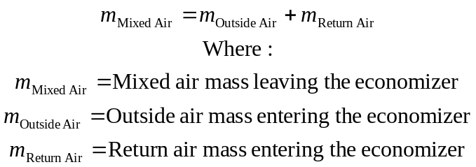
For most air handling systems, the temperature and pressure changes seen by the air as it goes through the system are not large enough to cause a significant change in the density of the air. Thus, cubic feet of air per minute (cfm) leaving the economizer section will equal the sum of the outdoor air cfm and the return air cfm.
Similarly, the energy content of the air stream leaving the economizer section is exactly equal to the sum of the energy content of the outdoor air stream and the return air stream entering the economizer section. From a mathematical standpoint:

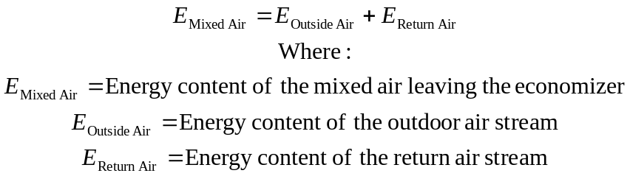

The energy content of the airstreams will be a function of a variety of things including temperature, moisture content, pressure, velocity, and elevation. For most air handling systems, the energy content associated with elevation changes will be insignificant. And, while there will be pressure drops associated with the economizer section, they will be relatively insignificant in the context of the thermal content of the air stream, which is our primary focus. In addition, the velocity entering and leaving most economizer sections will be nearly the same, thus velocity effects with regard to energy content will be insignificant. The energy content of the air stream can be considered a function of its temperature and moisture content. As a result, the thermal performance of the economizer can be predicted from the following equation:

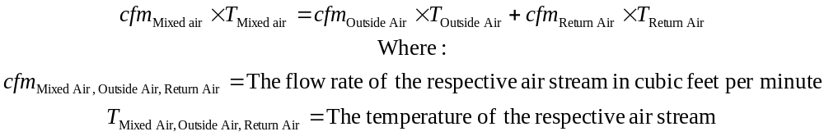
A similar relationship applies to the moisture content of the two airstreams.
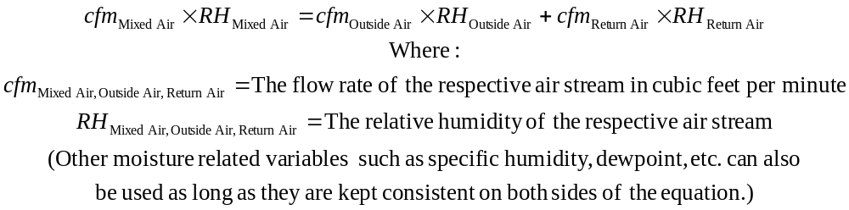
If flow rates are thought of in terms of percentages, the preceding equation can be simplified to:

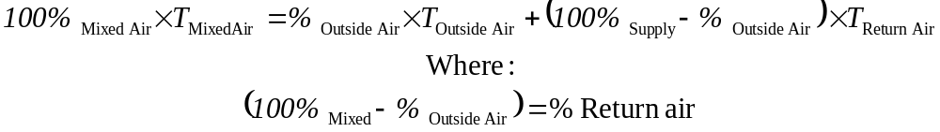

This equation can be solved for percent outside air:
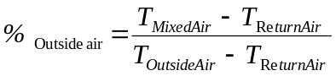

The equations assume that perfect mixing occurs; i.e. the temperature or moisture content of the leaving air stream will be the same regardless of where they are measured in the air stream. These relationships can be quite useful in the field as a troubleshooting tool to:
    - Predict the theoretical mixed air temperature or humidity when return temperature and humidity, supply temperature and humidity and outdoor air percentage are known: For instance, the predicted temperature can be compared to the measured average mixed air temperature. Significant deviations from the prediction may indicate that the system minimum outdoor air flow is improperly set.
- Determine the outdoor air percentage when the supply, return, and outdoor air temperatures are known: This approach works best when there are significant differences between the outdoor air temperature and the return temperature. Accurate measurement of the temperature is critical. Using the same temperature sensor to measure all temperatures will help eliminate temperature sensor calibration errors. Several mixed air temperature readings may need to be taken and averaged to accurately reflect the true mixed air temperature.
Figure 5.1 illustrates the operating curves for an economizer section serving a system with 75°F return air when operating at a 55°F set point and a 65°F set point. The curves are based on the conservation of mass and energy relationships discussed previously. The curves for set points between these two values will be similar curves located between the two that are shown.
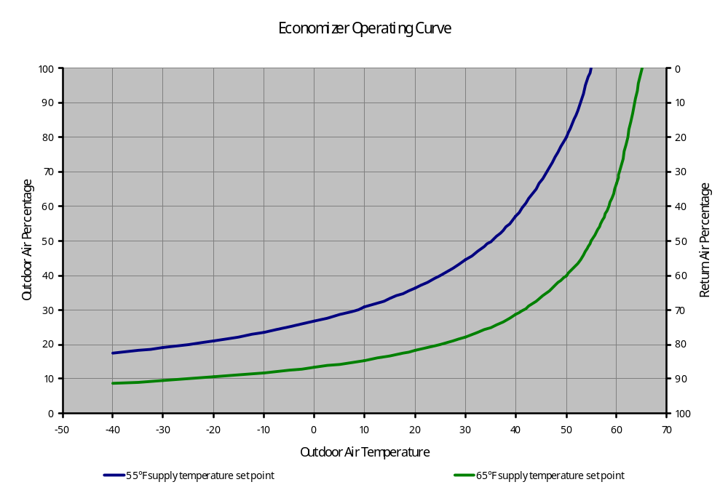
1

3

2

Figure 5.1- Economizer Operating Curves for a System with 75°F Return Air.
A 10°F outdoor air temperature change at low temperatures only requires a 4% change in the amount of outdoor air brought in to maintain set point (Circle 2). At higher outdoor temperatures, the same change in temperature requires a requires a 23% change in the amount of outdoor air brought in to maintain set point (Circle 1). Also note that it has to quite cold before the desired mixed air set point cannot be achieved by mixing minimum outdoor air with return air. For instance, on a system with a 20% minimum outdoor air requirement and a 55°F discharge set point, it will be approximately 28°F below zero before the mix of minimum outdoor air and return air will result in a temperature below 55°F (Circle 3).
Note the following with regard to Figure 5.1.
    - The relationships are non-linear: At low outdoor air temperatures, a change in outdoor air temperature requires a much smaller change in the percentage of outdoor air brought in to maintain set point compared to higher outdoor air temperatures. This introduces a non-linearity into the control loop that can make the loop more difficult to tune. A loop that was tuned and stable when it is cold outside may become unstable (hunting or oscillations) when the outdoor air temperatures warm up or visa-versa. This instability can cascade into other control loops in the system and cause other difficulties including:
1 Where independent loops are used to control each heat transfer element, instability in the economizer loop causes an unstable input to the control loop for the next heat transfer element. This can cause that control loop to become unstable, which then can cascade into the next loop in the system. A hunting system can waste energy due to simultaneous heating and cooling, wear out valve and actuator seals and other mechanical components, and create operational and comfort control problems.
2 If the economizer dampers have not been sized to have a linear flow vs. damper position relationship, then the damper system will have a pressure drop that varies as a function of the operating point on the economizer curve. As a result, if the economizer control loop starts to hunt, it will introduce pressure variations into the air handling system. In variable volume systems, these pressure variations can cascade into the fan capacity control loop and cause it to become unstable. In turn, this can result in unstable supply static pressure at the inlet to the terminal unit that can trigger instability in the terminal equipment flow regulation control loops.
- Typical office environment minimum outdoor air percentages will not require preheat until it is fairly cold outside: Air handling systems serving office environments typically operate with an outdoor air percentage in the range of 10-30% and discharge temperatures in the 55-65°F range. The operating curves in Figure 5.1 reveal that it has to be extremely cold outside before a typical office system will be below required discharge set point by simply mixing the minimum outdoor air flow with the return flow. This implies that most systems should not use preheat until the outdoor temperatures are quite extreme if everything is functioning properly. However, it is not unusual to find office air handling systems using preheat when the outdoor temperatures are over 40°F. There are a variety of reasons for this including:
- Systems are not achieving good mixing in the economizer and mixed air section.
- Systems have independent control loops for the economizer, heating coil and cooling coil where the sensors controlling the loops are out of calibration or the set points of the loops have not been properly coordinated.
- Systems do not have a mechanism in place to regulate the minimum outdoor airflow rate regardless of system flow rate.
- Normally operating VAV systems serving loads with high ventilation requirements that remain high regardless of the sensible load in the area served.
Figure 5.2 illustrates the mixed air temperature will be achieved by systems with good mixing operating at different minimum outdoor air percentages as the outdoor air temperature varies. Notice that Figure 5.2 shows the same information as Figure 5.1 but with different axes.
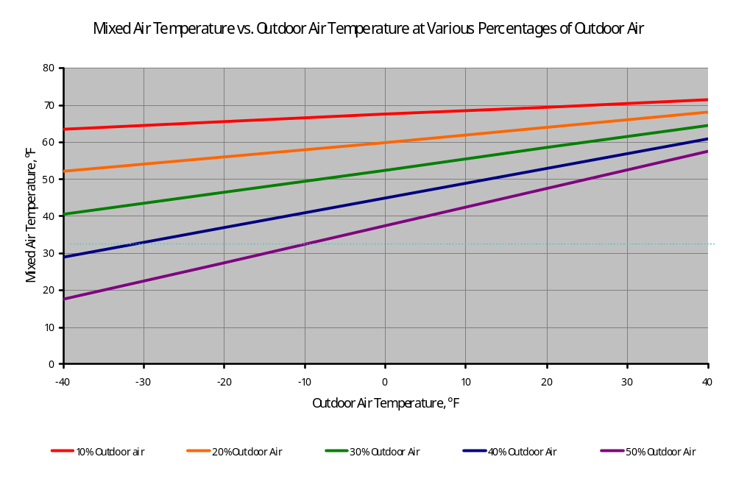
Figure 5.2 - Mixed air temperature vs. outdoor air temperature at different minimum outdoor air percentages
Return to Overview Table of Contents

Heat Recovery Functions
Economizers are typically thought of as a method to provide free cooling since cool outdoor air is mixed with warm return air to provide a cool supply air stream without running mechanical refrigeration. However, if one rephrases the preceding statement slightly to say warm return air is mixed with a cold outdoor air stream to raise the supply air stream’s temperature to that required to meet the space cooling loads without the need to preheat, then it can be seen that an economizer is also a heat recovery strategy. The recovered energy comes from the return air stream. The return air stream started out as the supply air stream at some temperature below the desired room temperature, typically 55-65°F. The air was then warmed by the internal gains in the space due to lighting, equipment and people. In Chapter 23 - Integrated Control Functions, we will discuss controlling the economizer outdoor air and return air dampers based on temperature requirements and controlling the relief dampers based on building static pressure requirements. By doing this, the following advantages are realized:
- Improved comfort due to exfiltrating warm air rather than infiltrating cold air at the perimeter and in lobby areas.
- Reduced perimeter heating loads because instead of infiltrating air at the perimeter, which is a heating load on the perimeter system, the air is exfiltrated at the perimeter. This exfiltrated air has been heated by the internal gains in the building either at the mixed air plenum where return air and outdoor air are blended or via the heat gains in the space as the supply air warms up to the space temperature.
  - Reduced return fan energy consumption because the return fan ends up moving less air back to the relief damper location. Through experience with retrocommissioning projects, fan energy use has been reduced as much as 20% to 40%.
Recovering energy from the return air stream is limited when the outdoor air quantities are great enough and/or the outdoor temperatures low enough that preheating the mixed air is necessary to achieve the required supply temperature. However, in many parts of the country, these are extreme conditions, not the norm.
Return to Overview Table of Contents

Mixing Functions
For an air-side economizer system to function well, it must mix the supply and return air streams effectively. Often economizer sections cannot mix the air streams in their designed configuration. In some cases, there can be a 50° - 60°F temperature difference between the warmest and coldest point in the mixed air plenum. The problems that result from poor mixing include:
- Systems where the economizer function is disabled and the chilled water plant is operated all year to serve the cooling loads.
- Systems that cannot cool spaces during winter months because the mixed air controllers have to be set to extremely high temperatures to prevent nuisance freezestat trips.
- Systems that simply will not run below certain outdoor temperatures due to freezestat trips.
- Frozen coils because freezestats are disabled to prevent nuisance freezestat trips.
  - Systems that are almost impossible to start in cold weather due to freezestat trips This problem is often related to lack of a mixed air low limit control loop on systems that control the economizer based on discharge air temperature.
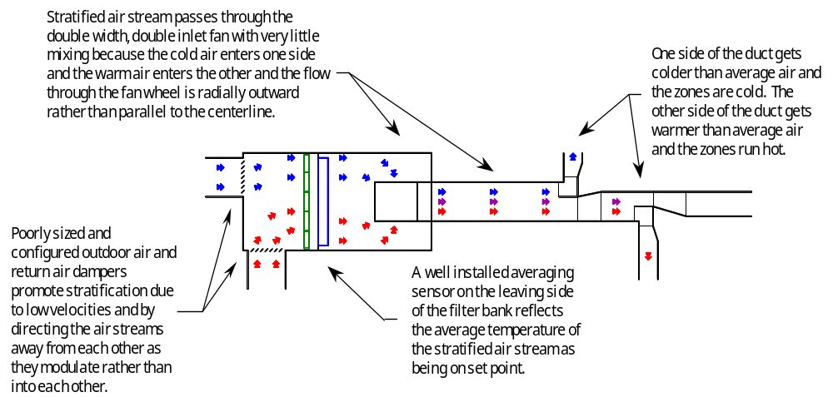
Figure 5.3 - Mixed Air Stratification Carried Through a DWDI Fan
Occasionally, poor mixing conditions can have far reaching and unexpected implications. Figure 5.3 is an example of a particularly interesting problem related to vertical stratification that was set up by a bad mixing arrangement and carried itself through the DWDI fan to the discharge duct. For a significant distance down the discharge duct, zones on one side were hot and zones on the other side were cold.
Most of the time, mixing problems can be identified and solved by:
- Taking a temperature traverse of the mixed air plenum in cold weather to better understand the problem. The procedure associated with this process is described in detail later in this section under Temperature Traverse Test. The results of this test can be used to direct the remaining steps in this list.
- Disabling and permanently closing damper some of the blades to improve the velocity through the damper. This makes the damper characteristic more linear and gives the air streams momentum to mix.
- Rotating the damper sections so that the damper blades direct the air streams into each other as they close. This creates turbulence and helps to promote the mixing process.
  - Adding baffles to divert the air stream several times before it reached the coils. This also creates turbulence, which promotes mixing. If the baffles are arranged so that the velocity through them is low (800-1,000 fpm) then significant benefits can be realized with at significant additional pressure drop.
Applying these techniques to solve a problem is described later in this section under Air Blenders and Baffle Plates. By taking some or all of these steps on problem systems or by focusing attention during design phase commissioning, it is possible to obtain systems that have a 5°F or less temperature variation between the warmest and coldest point in the plenum, even in extreme winter weather. Items to watch for during the design phase commissioning process include
- Make sure someone is taking responsibility for sizing the dampers. Sizing can either be done by the designer on the actual contract documents or through assignment to the controls contractor. If damper sizing is assigned to the controls contractor, then the commissioning agent should review the sizing calculations and other details included in the control submittals. Additional discussion about damper sizing can be found in Dampers.
- Be sure that a mixed-air, low-limit cycle is included in the control sequence. Additional information on this sequence and its benefits can be found in this section under Common Difficulties.
- Be sure the design provides sufficient distance for the air to mix between the mixing dampers and the first coil in the air handling system. General rules for this are discussed under air blenders.
- Be sure that the design reflects an economizer damper configuration that promotes mixing both by the arrangement of the dampers relative to each other as well as by the way the dampers rotate to close. Ideally, the designer should detail the required arrangement on the construction documents. However, if the engineering time or budget does not support this, then the details can be delegated to the control contractor. When delegated, the contract documents should require that the control contractor include the necessary detailing as a part of the controls submittal package and the commissioning agent should review this information.
- Make sure the documents reflect installing the mixed air sensors and freezestats in a manner that fully covers the mixed air plenum and allows the mixed air sensor to accurately reflect the conditions that the freezestat will see. This may require multiple sensors for larger systems. Running the sensing elements for the mixed air sensor and freezestat together helps to ensure consistent system performance by subjecting these two related sensors to identical conditions. The support system detailed for the sensors should ensure that they are only affected by the air stream conditions. Supports from coil frames and tubes often conduct heat to or away from these elements can cause false readings. Radiant effects from high temperature hot water coils and steam coils can also skew the sensor readings even if there is no direct contact between the sensor and the coil and the sensor is located in the air stream ahead of the coil.
- Make sure the documents detail the installation of actuation systems in a manner that assures linear or near linear relationships between actuator stroke and blade rotation (and thus flow if the dampers are sized). Additional information regarding this topic can be found later in this chapter in Section 8.6.2 Actuators.
- Make sure that the designer has considered the impact of flow reductions in VAV systems on damper performance at part load. Damper performance and linearity are velocity dependent, as is discussed in Section 8.6.1 Dampers. The reduced flow rates in VAV systems at part load translate into reduced damper velocities. Specifically, at 50% flow, the damper velocities are 50% of what they are at design flow and the pressure drops are 25% of the design value. This change can cause a significant decay in the damper linearity characteristic for some systems. The problem is much easier to address at the design phase when the necessary adjustments are made on paper.
It is important for the commissioning agent to follow through on these items as the project moves from design into construction by reviewing shop drawings and verifying proper installations during site inspections. In the end, these efforts will be rewarded by a system with fewer commissioning issues to address at start-up and during the first year of operation.
Return to Overview Table of Contents

Building Pressure Control Functions
As was described in Section 8.4, the temperature control function of operating the outdoor air and return air dampers in an economizer cycle generally results in the need for building pressure control to allow the extra (above the minimum outdoor air requirement) outdoor air brought into the building for cooling purposes to exit the building. Several approaches typically used to accomplish this are listed below.
1 Barometric Dampers - This is generally the simplest approach to the problem and works well if the building is reasonably tight and not geometrically complex or tall enough that chimney effect becomes a factor and if the path from the occupied space to the relief damper location does not have much pressure drop at design flow. The dampers generally consist of blades and a frame that are mounted and pivoted in such a way as to allow gravity to close the damper and small, positive building pressures to open the damper. Some dampers are counter balanced and can be adjusted to control at specific pressures. The low end of the control range is typically in the 0.05 inches w.c. range. The high end is generally a function of the damper size at the design flow rate as well as the adjustment of the damper.

Figure ? - Typical barometric damper
2 Modulating Dampers Controlled Directly by the Same Signal as the Outdoor Air and Return Air Dampers - This is generally the most common approach to controlling building pressure, especially on older systems. The approach works well for constant volume systems. It also can provide reasonable performance for VAV systems serving relatively small non-geometrically complex low-rise buildings. However, problems can occur because the signal controlling the relief dampers (a pressure control function) is also the same signal as the one controlling the economizer dampers (a temperature control function). As a result, building pressure control problems can be aggravated in high rise buildings, leaky buildings, and buildings with relief fans (as compared to return fans) serving VAV systems. Consider what happens to the partially occupied building in the following example on a 55°F overcast day.
The building’s air handling system is VAV with an economizer cycle equipped with relief fans. The relief fans and dampers are controlled by the same signal that is used by the economizer cycle to control the outdoor air and return air dampers to maintain a 55°F discharge temperature. On this particular day, since the outdoor air temperature is equal to the required discharge temperature, the economizer cycle opens the outdoor air dampers and relief dampers to 100% and the closes return dampers. The relief fans are being commanded to run at full speed. But, since there is no solar load and the internal gains are low due to the low occupancy level, the VAV function of the air handling system is meeting the supply flow requirements by operating the supply fan at 50% of its design flow rate. As a result, there is a serious mismatch between the air being brought into the building through the wide open outside air dampers by the supply fan running at 50% capacity and the air being removed from the building through the wide open relief dampers by the relief fans running at 100% capacity. In this particular case, the difference was so significant that most people attempting to enter the building could not open the entry doors due to the forces placed on them by the severe negative pressure difference relative to atmosphere.
3 Modulating Damper System Controlled by Some Other Signal such as Building Static Pressure - This is the approach that can be used to solve the problem described in the example above. Under this approach the relief dampers (and relief fans if the system is configured that way) are operated based on building static pressure instead of by the economizer signal. As a result, the system only begins to relieve air when the building becomes slightly positive. Only as much air is relieved via the relief system as necessary to maintain the slight positive pressure relationship in the building relative to atmosphere.
This approach is especially beneficial in older, leaky buildings, large complex buildings and high rises regardless of the HVAC system type. In these situations, the chimney effect and other factors can become significant influences on the pressure relationship between the inside and outside of the building. By controlling the relief damper off building static pressure, problems with significant positive or negative pressure from the economizer mode can be avoided.
Return to Overview Table of Contents

Control Strategies
Economizer cycles typically have several different control requirements associated with them including:
- The operating control strategy that governs the cycle in normal operation.
- Limit control strategies designed to accommodate transient conditions such as start up or sudden load changes.
- Interlock strategies designed to terminate the economizer cycle when it no longer provides any useful benefit or the system it serves is not in operation.
Alarms designed to detect problems.
Return to Overview Table of Contents

Operating Control
In the general case, the operating control of the economizer system is designed to modulate the supply and return dampers in some manner to maintain a temperature in the air handling system. Exactly what temperature is to be maintained and exactly how this is accomplished can vary from system to system but typical examples include:
- Control to maintain a specific mixed air temperature.
- Control in sequence with the other heat transfer and energy conversion elements in the system to maintain a specific discharge temperature.
  - Control in sequence with the other heat transfer and energy conversion elements in the system to maintain the desired temperature in the occupied zone.
In addition to these temperature control related functions, the control of the relief dampers must also be integrated with the operation of the return and outdoor air dampers. This is discussed elsewhere in this chapter under Building Pressure Control Functions. In addition, the integration of these operating control strategies with the over-all system and building control functions are discussed in detail in Chapter 23 - Integrated Control Functions.
VAV systems can pose particularly challenging economizer control problems if the system must operate at a high turn-down ratio. Since the linearity of the dampers as well as the mixing performance are related to velocity, the velocity reduction associated with operating at a lower flow rate can cause a VAV system with reasonable performance characteristics at higher load conditions to degrade to unacceptable levels of performance at low load in extreme weather. The problems occur partly because the momentum and turbulence that promote mixing drop of significantly as the velocities in the mixing box and through the dampers drop. In addition, the damper characteristics become less linear.
When economizers fail to perform reliably at low turn down ratios, the solutions typically involve either preventing the system from turning down as much or giving up on the economizer and running mechanical cooling in its place. These solutions can be energy intensive and have some operational problems of their own at the central plant. But, many times, they are the only viable solutions for an existing system, especially if the system doesn't spend a lot of time running at the low turn-down ratio.
One of the most common examples of a system where this might become an issue is a VAV system that closes off flow to tenant zones when they are unoccupied and allows the central fan VAV control strategy to back the fan down to a lower flow operating point. If the building is highly subdivided, it is possible for this type of system to see a load as low as 10% of design. One approach that has been used to address this problem on larger systems with multi-section dampers is as follows. Each section of the multi section outdoor air, return air and relief air dampers is equipped with an independent actuator. The output signal to each damper assembly is split so that half of the sections are controlled by one output and the other half are controlled by the other. The control logic is arranged to disable and force closed half of the damper sections in each assembly when the system reaches 50% turn-down. This will reduce the available damper area by 50%, which pushes the velocities back up at low loads. As a result, the damper pressure drops increase and the alpha at low load improves. In addition, the higher velocities also promoted mixing. This is easier to implement in a new design rather than as a retrofit, but is not impossible to retrofit, especially if the existing dampers are multi-sectioned.
As a related issue, the relief dampers need to be controlled in a manner that allows the system and building to deal with the extra outdoor air brought in by the economizer cycle as was discussed previously. Additional detail on this topic is also contained in Chapter 23 - Integrated Control Functions.
Return to Overview Table of Contents

Limit Control
Sometimes it is necessary to use a limit control strategy for economizers in cold climates. When the economizer is controlled based on the discharge air temperature from the supply fan, employing mixed air low limit control will reduce or eliminate freezestat trips. If the economizer is controlled off the mixed air temperature, then the mixed air low limit control strategy does not apply.
Consider the following scenario. During an extended shut down, the air in the vicinity of the discharge sensor as well as the various components in the unit will tend to stabilize at the temperature of the surroundings. Typically, this will be in the 65°F - 75°F range for most mechanical rooms. When the system restarts, the discharge temperature sensor sees the discharge temperature as being significantly above set point (usually in the 55°F - 60°F range) and begins to drive the economizer dampers toward the 100% outdoor air position. Since there is some distance between the mixed air plenum and the discharge temperature sensor, and since the air from the mixed air plenum will be warmed up as it cools down the coils, casing, fan housing and other components of the air handling unit, it will take some time for the discharge temperature to drop to match the mixed air temperature. As a result, the unit will tend to drive toward and stay at the 100% outdoor air position until the temperature at the discharge sensor drops toward the discharge temperature set point. However, since the outdoor air temperature is below freezing, the mixed air temperature can drop below the set point of the freezestat since the outdoor air is delivered directly to the mixed air plenum. The outside air trips the freezestat and the unit must then be manually restarted since a freezestat trip usually requires a manual reset. In most cases, it will take 5-10 attempts to start the unit before the discharge temperature will catch up with the mixed air temperature fast enough to prevent the problem. In some cases it is impossible to get out of this mode by repeated freezestat resets; the thermal inertia of the system is too great when combined with the dynamics of the intake system, control dampers and control system.
Nuisance freezestat trips can become very frustrating to operators, who usually solve the problem by either defeating the scheduling program, preventing the economizer operation and using mechanical cooling, manually cracking the hot water valve open so that there is always enough heating to protect the freezestat, or by jumping out the freezestat. The first three solutions will waste energy. The last solution can lead to a failure of the water coil or coils due to freezing, and in extreme cases can freeze the entire building plumbing system. If the unit operates on a schedule, then the problem will show up during the warranty year and there is some hope that it will be addressed and corrected via the warranty process. However, for systems that operate 24 hours per day, 7 days per week, the problem will most likely occur the first time there is an extended power outage during cold weather. This may not occur for years after the unit is installed. When a nuisance freezestat trip occurs, it is quite likely that a less than optimal solution will be employed in an effort to return the critical system back to operating status.
A properly employed mixed-air low-limit cycle can prevent freezestat trips and not reduce the performance of the system. A control loop is created based on mixed air temperature that overrides the normal economizer control sequence to prevent the mixed air plenum from dropping below some limit, like 40°F. This limit cycle will hold the mixed air temperature at a safe level until the temperature at the discharge sensor drops toward the discharge temperature set point.
Return to Overview Table of Contents

Operational Interlocks
The operation of the economizer cycle needs to be interlocked with the operation of the system it serves so that the outdoor air and relief dampers are closed when the system is shut down, thereby preventing problems with unconditioned air entering the building during unoccupied hours. However, there are several details that need to be addressed in order to provide the most robust and reliable system. These issues often show up as commissioning or operational problems if they are not addressed during design.
1 The interlocks that shut down the economizer dampers need to function regardless of the position of any hand-off-auto selector switches at the DDC controller, fan drives or starters. Interlocks that depend on the operation of the DDC system are easy to implement. If the system is being operated manually, either for commissioning purposes, temporary heat purposes or in an emergency, perhaps caused by the failure of the DDC controller, then the interlock function can inadvertently be aborted. In these cases, the system runs without freeze protection.
2 Interlocks that are based on pressure or current signals need to be set to function reliably at all system operating points. It is not uncommon for pressure differential across a filter bank, cooling coil, or fan or for fan motor current to be used as proof of system operation and as a basis for the operating interlocks on a system. These are very good indicators, but they need to be set up to provide reliable information in all operating modes. For example:
Differential pressures vary as a function of the square of the flow rate, and motor horsepower (and thus, amperage) varies with the cube of the flow rate. As a result, when a variable volume system unloads, the signals available for differential pressure based and motor current based proof of operation inputs can decrease quickly. In order to ensure operation of the economizer and other features that use this information as an interlock, the functional testing process should verify that a reliable signal is provided at design flow as well as at the minimum flow.
Some system differential pressure signals prove fan operation but do not necessarily prove flow. Consider a system where the fan has started but the discharge smoke damper has failed to open for some reason. A proof of operation input from based on fan differential pressure would indicate that the system was running since the fan does not have to move air to generate a pressure difference. A proof of operation input based on coil or filter bank differential pressure would not indicate the system is running since there must be flow to generate a pressure difference across these elements.
There are various schools of thought regarding which of these two approaches provide the best proof of operation signal, all of which have merit. Commissioning agents should be aware of how the specific system they are dealing with functions and develop the functional testing plan accordingly.
3 On some larger systems, the outdoor air and return air dampers are selected and controlled to provide code dictated smoke isolation of the air handling equipment from the duct system. When this is done, several additional factors come into play with regard to the economizer cycle.
Any damper that is used for fire or smoke control functions must be listed for that service. This listing includes the actuators and details of how the damper is installed. As a result, these installations are less flexible in terms of field modifications to address economizer problems. In addition, any repairs or component replacements made must be done with components designated and installed in a manner dictated by the manufacturer in order to retain the U.L. rating.
If the return dampers are being used for smoke isolation purposes, then they will need to be interlocked to close rather than open when the unit is shut down. This is contrary to the conventional operating mode for an economizer, which closes the outdoor air and relief dampers and opens the return dampers when the unit is shut down.
4 On systems with large fans capable of high static pressures, interlocking the return dampers to close when the unit is off for smoke isolation purposes sets the system up for a failure if both the outdoor air and the return dampers fail to open prior to the fan start. Under a no-flow condition, a fan will generate its rated shut-off static pressure. If the inlet side of the fan is closed off and the outlet is reference to atmosphere via the open but inactive duct system, then the fan will attempt generate its rated static as a negative pressure on its inlet. Many large fans can generate static negative static pressures in this manner that are well above the rating of the intake systems, mixing boxes and air handling unit casings they serve. To prevent damaged to the air handler, there are several measures that can be taken.
- Fabricate the duct and plenums on the intake side of the fan for a pressure class rating in excess of the fan’s rated shut-off static pressure. This may be the most viable and trouble-free approach on systems with fans rated for modest static pressures at shut-off.
- Install manual reset type static pressure limit switches and wire them into the safety circuit to shut down and lock out the fan in the event such a condition where to occur. This may or may not be the best course of action since the switch needs to respond quickly enough to shut down the fan before it can do damage. A large fan wheel can take several minutes to decelerate and during that spin-down time, the wheel will attempt to move air and/or generate pressure. The fan spin-down test included in Chapter 6 - Outdoor Air Intake Section is targeted at identifying this coast down time.
- Install pressure relief doors. These devices are discussed in further detail in Chapter 6 - Outdoor Air Intake Section.
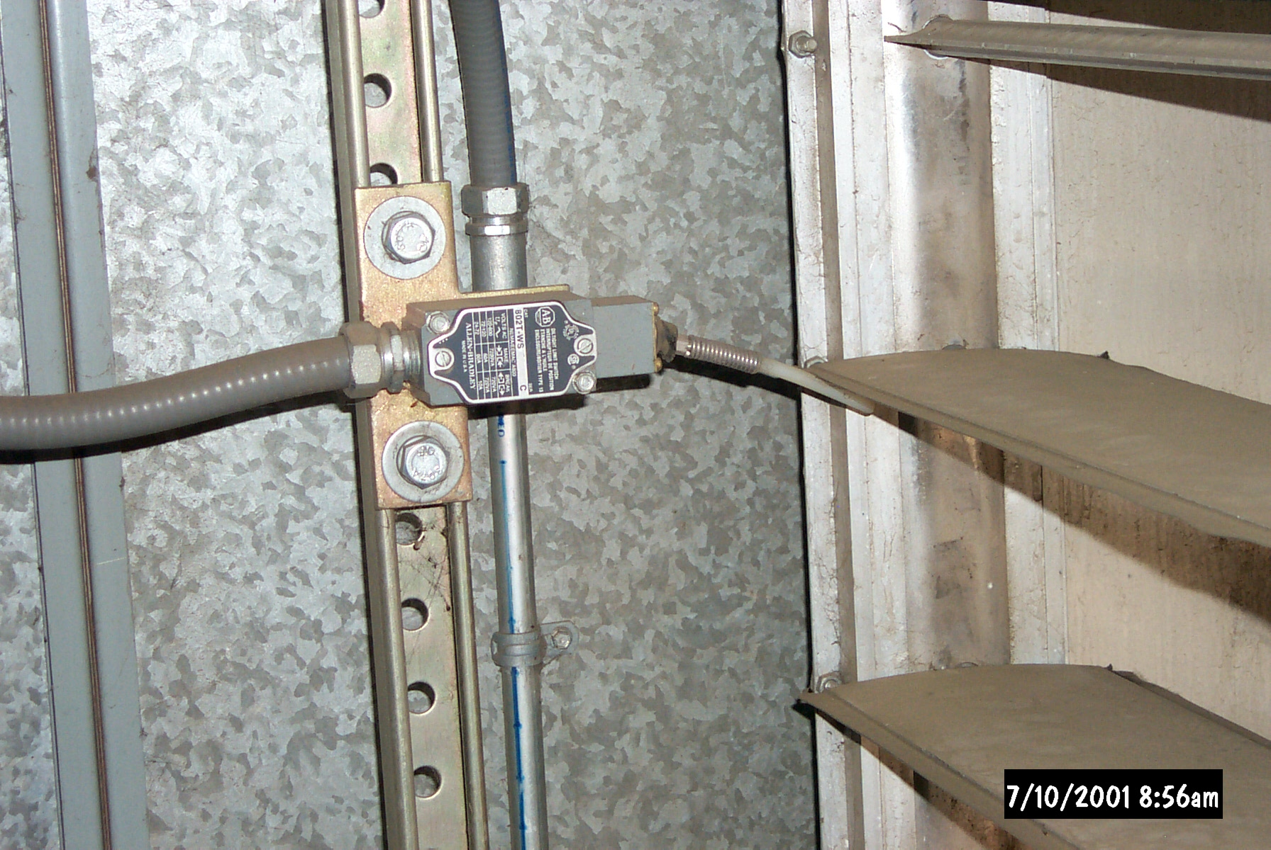
- Figure ? - Typical damper limit switch installation. Note that the switch is sensing blade position and that the unistrut mount makes it very easy to adjust the switch for the desired trip point.Install limit switches wired in a permissive interlock circuit so that the fan will only be allowed to start after the dampers are open to the point where no damage to the ductwork and air handler casing can be done. The switches should monitor blade position, not shaft or crank arm position since crank arms and shafts can come loose from the blades they serve. Figure ? illustrates a typical installation of this type of switch. Permissive interlocks are discussed in detail in Chapter 3 - Guidelines for Control Algorithm Design.
If limit switches are used for an economizer equipped air handling unit, then the both the return and outdoor air damper need to be provided with limit switches. For this interlocking scheme to be effective, both dampers need to have limit switches, and the limit switches need to be wired and adjusted so that if either damper is open sufficiently, then the system will be allowed to start (or remain in operation). If the limit switches were installed only on the return damper, then the system would “think” it had a problem when the economizer drove to the 100% outdoor air position. If only the outdoor air damper or minimum outdoor air damper was equipped with limit switches, then the system could inadvertently start with both dampers closed if it was starting during extreme weather and/or starting in a warm-up or cool-down mode where no outdoor air was introduced until the area served was at the desired temperature for occupancy and occupants were present. The interlock wiring associated with this type of permissive interlock typically involves a network of series and parallel contacts with the complexity of the network being a function of the number of damper sections and limit switches involved in the interlocking scheme. The start-up and commissioning process needs to include a test similar to the Permissive Interlock Test included in Chapter 5.04 - Intake Section to verify that the adjustment of the switches on the different damper assemblies is coordinated and will not inadvertently shut down the system when the economizer is under modulating control or the outdoor or return dampers are closed.
Return to Overview Table of Contents

Safety Interlocks
Like operational interlocks, safety interlocks need to be arranged to function regardless of the position of any hand-off-auto or inverter-bypass selector switches associated with the air handling system’s fan motors. In many instances, it is also desirable to have them trigger some sort of alarm to bring the problem to the attention of the operators.
Return to Overview Table of Contents

Low Temperature Cut-outs
The most common safety interlock associated with the mixed air section is the low temperature cut-out, typically referred to as the freezestat. This device is discussed in greater detail in the Components section of this chapter.
While unusual, there are some situations where a properly installed and functioning freezestat will not protect the coil it is associated with from freezing. Often, the cause of coil freezing is an upstream problem that cannot be addressed by the actions of the freezestat. The most typical situation of this type involves a system where the outdoor air dampers fail to close or seal completely when the unit shuts down during subfreezing weather. The dampers can fail to close for a variety of reasons including actuator failures, blade and jamb seal failures, linkage failures, operator errors, or binding of the damper blades. If damper failure combines with a pressure difference between the inside and outside of the building, like stack effect in a high rise, or an operating exhaust system with no make-up air, then outdoor air can flow through the open dampers and unit into the building. Since the flow is not directly related to the operation of the fan, a conventional freezestat installation (where the freezestat is wired to shut down the fan when it trips) will afford little protection. There are several approaches that can be used to address this problem.
1 Arrange the freezestat to cause full flow to the heating and cooling coils when it trips. In addition to shutting down the air handling unit, the freezestat can be arranged to fully open the valves on the heating and cooling coils and to start the chilled and hot water distribution pumps. These safety interlocks provide several layers of protection. The most obvious is that activating the heating coil will provide heat inside the unit and warm up the subfreezing air stream until the operating staff can respond to the alarm. Moving water through the coils provides a second layer of protection. Compared to water that is static in the coil circuits, moving water is less likely to freeze because it is not in the coil long enough to freeze. The thermal energy stored in the piping circuit, even if the water is at ambient building temperatures, will protect the system. If subfreezing air entering the unit persisted long enough, the heat transfer out of the water system to the subfreezing air stream would eventually drop the temperature of the water system to dangerous levels.
Some control sequences vary this approach by commanding the coil valves fully open any time the unit is shut down. While this strategy accomplishes the same intent as the interlock of flow to the coils with the freezestat, there are some operating difficulties associated with it.
- The wide open valves result in full flow through an inactive coil. This creates a thermal short circuit in the heating and chilled water systems that can make the systems difficult to operate efficiently, especially if they are variable flow systems.
- If there is no air flow through the unit when it is off, then the air in the vicinity of the coil will approach the cooling or heating water temperature. The temperatures inside the unit casing will approach the temperatures of the heating or cooling medium in the coils. In the case of the heating coil, this can result in air handling unit casing temperatures that are very high. This slug of very hot air, in addition to the other start-up transient conditions, can make the system difficult to start. The problem created is very similar to the start-up problem that is described in the limit control section of this chapter. Wide open valves also can put a significant parasitic burden on the heating plant, with energy losses through the air handling unit casing.
Problems associated with a cooling coil operated with a wide open valve when the unit is off are less severe. The lower tube and fin temperatures mean that the coil has a lower apparatus dew point (a measure of its ability to dehumidify). As a result, the air inside the unit casing is cooled and dehumidified more than it would be if the unit were in operation. The open valve wastes energy and can cause condensation and water damage problems, especially for rooftop equipment in hot and humid environments.
2 Arrange the freezestat to start the return fan when it trips. This approach provides temporary protection for the coils by using the warm air in the building to pressurize the mixing plenum until the operators can respond to the alarm. It is a reasonable temporary measure to prevent frozen coils, but can create problems if it persists long term since the air that the return fan is moving is drawn from elsewhere in the building.
3 Include a control sequence that uses the hot water coil to hold the air handling unit casing temperature above freezing any time the unit is not operating. This approach is a variation on providing full flow to the coils upon a freezestat trip that addresses some of the problems that were identified. In this approach, an independent control loop is set up to modulate the heating valve to hold the mixed air plenum or coil plenum at some safe value, like 40°F - 45°F when the unit is off. With this strategy, the system will be easier to start since it will not have a large amount of very hot air that has accumulated in the unit while it is off. In addition, energy will be saved: heating energy in the form of lower losses due to lower temperatures at the unit casing, and pumping energy (assuming a variable flow system) since the valve will be modulated, probably nearly closed, most of the time rather than wide open. Using a mixed air low limit cycle also makes a central heating plant easier to control since the wide open valve(s) serving a coil with no air flow represent a short circuit on the hydronic system. The short circuit artificially raises the system return water temperature and creates flow conditions in variable flow systems that look like design load conditions without the corresponding thermal loads. This is similar to the overflow problem on a variable flow chilled water system. This strategy will also make the start-up swings of the entire system, including the economizer dampers, less pronounced.
Obviously, the best approach to guarding against freezing air entering a unit due to damper failure is to prevent the failure. On new construction projects, the issues that cause damper failure are addressed by good field inspection practices followed up by a thorough functional testing plan. Field inspections should target:
    - Verification of the blade and jamb seals and general damper construction.
  - Verification that the damper assembly is installed in a manner that prevents racking and binding.
Functional testing should target:
    - Verification of damper actuator stroke and smooth operation.
- Verification of proper interlocks.
  - Verification of any special safeties and cycles incorporated into the system to counteract operating problems like a unit shutdown with the outdoor air dampers stuck open.
In existing systems, the issues typically are related to Operations and Maintenance (O&M) practices that can be addressed by targeting the items listed above as a part of the ongoing O&M program.
Return to Overview Table of Contents

Static Pressure Switches
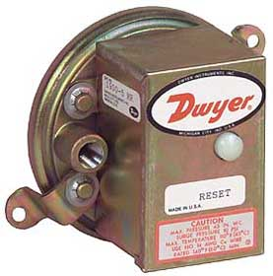
Figure ? - Typical static pressure safety switch (Image courtesy of the Dwyer web site)Another common safety associated with the mixed air section is a low limit differential pressure switch such as the one illustrated in Figure ? This type of interlock is applied to systems where the fan is capable of significant static pressures and a control or damper limit switch interlock failure would make it possible for a fan to attempt to start or remain in operation with both the return and outdoor air dampers closed. These switches are equipped with reset buttons, just like freezestats and once tripped must be manually reset. It is important to understand that these switches do not provide absolute protection against duct system collapse. The air hammer phenomenon discussed in Chapter 5 - Intake Section happens too quickly for this switch to provide protection.
In addition, large centrifugal fans can take some time to spin down to a stop after power is removed due to the inertia of the fan wheel. They continue to generate pressure and flow during this spin down cycle. As a result, the setting of this switch needs to be adjusted to shut down the system before the dangerous conditions exist so that the conditions created as the fan spins down do not cause the duct to collapse. It is important to coordinate closing the outdoor air and return dampers with the fan spin down time on systems where both dampers are closed when the fan is off. Otherwise, the pressures created as the fan spins down and the dampers stroke closed can cause nuisance trips of this safety device. The fan spin down test included in Chapter 5 - Intake Section can be used to identify the time required for the fan to spin down so it can be coordinated with the damper action.
Return to Overview Table of Contents

Ambient Condition Interlocks
In its most basic form, the economizer cycle is intended to eliminate the need to operate mechanical refrigeration equipment by providing the necessary cooling using outdoor air when it is suitable for the purpose. In theory, this should be possible anytime the outdoor conditions are below the current discharge temperature set point. The economizer can also provide energy savings even when mechanical cooling is operating by minimizing the load on the mechanical cooling equipment. This is because it will often take less energy to cool a 100% outdoor air stream as compared to the return air stream from the space, even though the ambient temperature is above the required supply temperature. The psychrometric chart in Figure ? illustrates one such case for a system serving an office area.
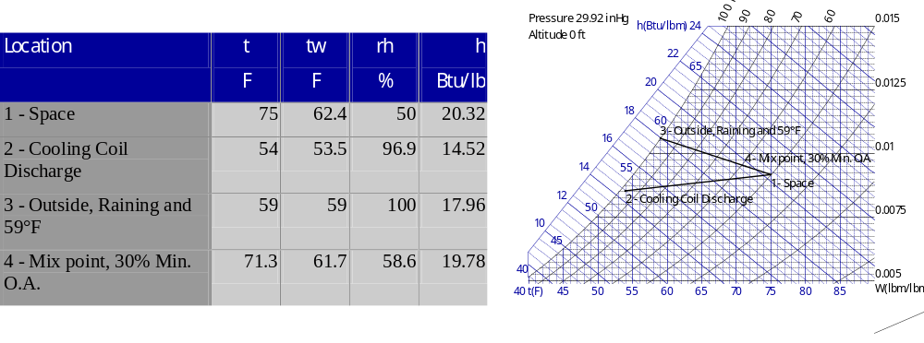
Figure ? - Cooling return air mixed with the minimum outdoor air requirement vs. cooling 100% outdoor air to 54°F on a rainy 59°F day. Cooling and dehumidifying 100% outdoor air to 54°F requires 3.44 btu of energy be removed from every pound of air. Cooling the mix of 70% return air and 30% outside air requires that 5.26 btu/lb be removed. So, even though the outdoor temperature is above the required supply temperature, the system will use less energy if it remains on the economizer cycle using 100% outdoor air. Mechanical cooling is necessary, but not as much.
In most locations, the ambient conditions will reach a point where the economizer provides no energy savings benefit. To address this issue, an interlock needs to be provided to disable the economizer and return the system to a recirculating mode with minimum outdoor air. There are a variety of ways to accomplish this.
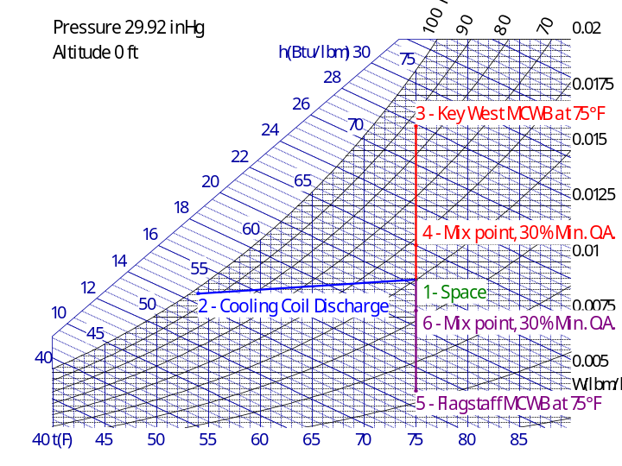
Figure ? - The impact of disabling the economizer based on an outdoor temperature equal to a space design temperature of 75ºF in a dry climate and a humid climate. In Flagstaff, this interlock would save dehumidification energy (as compared to running the system in recirculation mode with minimum outdoor air) because the outdoor environment is so dry. In Key West, it would cost energy because the climate is so humid.1 Outdoor Temperature Based Interlock - This approach is usually the least complex and costly to implement. Typically, the economizer cycle is terminated based on some ambient outdoor air temperature, also called the changeover setting. The trick is to select a temperature that will maximize the energy savings obtained from the economizer. The temperature will vary by location depending on the local climate. Often, when this approach is used, the system is set to go off of the economizer cycle any time the outdoor air temperature is above the design space temperature. This is probably a reasonable approach in dry climates with low mean coincident wet bulb temperatures and little rain. However, in a hot and humid climate or a climate where it rains frequently in the warm months, this approach can place a significant energy penalty on the air handling system since it will have to do much more dehumidification to cool the outdoor air at or near the design space temperature compared to cooling the return air from the space mixed with the minimum outdoor air requirement. Figure ? illustrates this by comparing what would happen in Key West Florida vs. Flagstaff Arizona based on the statistical Mean Coincident Wet Bulb temperature (MCWB) at a typical space design condition of 75°F.
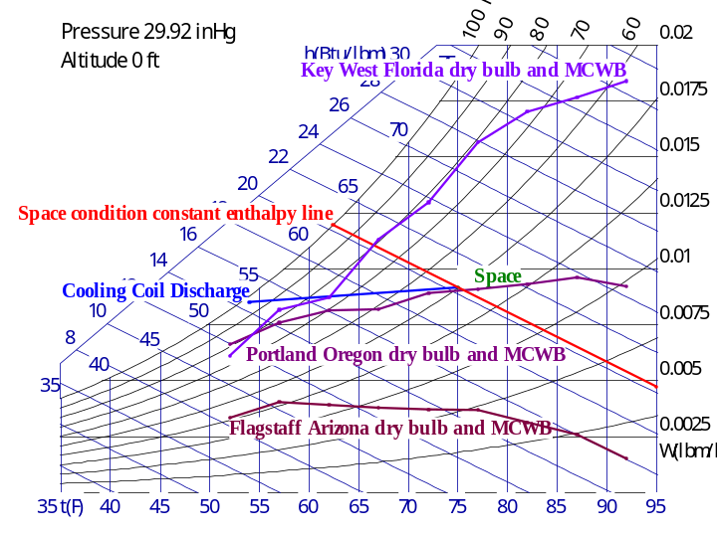
Figure ? - Using statistical weather data and a psychrometric chart to determine a suitable dry bulb temperature based economizer disable set point. On this chart, the red line represents a constant enthalpy line at the design space condition. Points to the left of this line represent states with lower enthalpies and therefore, a lower cooling and dehumidification energy requirement than the air returned from the space. Points to the right of the line represent the opposite. The lavender lines represent average outdoor conditions for various locations. Setting the economizer disable temperature at the point where the constant enthalpy line crosses the average climate condition line for a given location will place the system in the correct operating mode most of the time. The lines on this graph were developed from bin weather data in the Air Force Engineering Weather Data Manual but could also be developed from other readily available sources such as NOAA. Since the energy needed to cool the air depends on the temperature and moisture of the incoming air, these factors must be taken into account when determining a dry-bulb economizer changeover setting. , Figure ? illustrates one possible method of determining an energy-efficient dry bulb changeover temperature. A line representing the statistical average of a specific location’s climate conditions is plotted on a psychrometric chart. In the example, bin data from the Air Force Engineering Weather Data Manual was plotted using the Mean Coincident Wet Bulb (MCWB) temperature for each dry bulb temperature bin. Then, a second line is plotted that is a constant enthalpy line for the state of the air in the space at its design condition. The economizer change over controller is set for the dry bulb temperature where the two lines intersect. From a statistical standpoint, it will take less energy to cool the outdoor air at the conditions to the left of the intersection for the particular location being analyzed. Conditions to the right will take more cooling energy to cool the outdoor air. Therefore, the dry bulb controller should be set up to shut down the economizer for temperatures above the intersection point and allow it to function for conditions below the intersection point.
As can be seen from Figure ?, the exact value for this point can vary significantly from location to location. In the very hot and humid climate of Key West, the change-over point is somewhere in the 66-67°F range. In the mild climate of Portland, the changeover point is 75-76°F.
Based on enthalpy values shown in Figure ?, the arid Flagstaff, Arizona climate should always use outdoor air and never recirculation. However, there is typically a point where the sensible cooling capability of the coil would be challenged provide a satisfactory discharge temperature. Often, cooling coils selected for this type of environment in a recirculating system are not particularly deep - perhaps 4 to 6 rows - due to the low, nearly non-existent dehumidification requirements. In addition, since the Flagstaff climate is so dry, 50% space relative humidity is unlikely unless there are some major sources of humidity in the space. So, some additional analysis of the actual space design condition and the sensible cooling capacity of the cooling coil is appropriate before selecting the economizer changeover temperature.
It is important to understand that the statistical weather data reports average conditions. The changeover temperature selected by plotting this data on a psychrometric chart will be correct most of the time, but probably not all of the time. However, this method provides more insight and better criteria for the correct changeover set point selection compared to simply shutting down the economizer function when the outdoor temperature is warmer than the required supply temperature or warmer than the space design temperature. When properly applied and then verified by the commissioning process, the optimized set point selection saves energy.
2 Enthalpy Based Interlock - When properly applied, using an enthalpy-based interlock has the advantage of providing an exact solution to the changeover problem, while the preceding approach provided an approximate solution. Unfortunately, enthalpy is a property that is more difficult to understand and measure than temperature. Several approaches to applying enthalpy-based economizer control can provide reliable performance if they are properly implemented, adjusted, and maintained.
The importance of proper adjustment and maintenance of enthalpy sensors cannot be overemphasized. Verification of operation requires a basic understanding of psychrometrics and access to a sling psychrometer or some other reliable indicator of atmospheric moisture content. Most of the maintenance problems are related to the portions of the equipment that sense humidity and often can be traced to contamination of the sensing element by dust and water or failure due to exposure of the plastics used to the direct or reflect rays of the sun and their associated ultraviolet component. The Enthalpy Change Over functional test included later in this chapter as well as the information in the following paragraphs and in the Sensing Elements section of this chapter are targeted at providing guidance for an enthalpy-based economizer interlock.
There are a variety of ways to implement an enthalpy based change-over from economizer to non-economizer operation.
- The most common approach simply assumes an enthalpy state of the return air based on design conditions and then allows the economizer to function only if the measured outdoor air enthalpy is less than the assumed return air state. This approach avoids the cost of an enthalpy sensor or switch for the return air and allows the change over decision to be made by one master switch for the building. The approach will provide the desired result as long as the fundamental assumption regarding the constant enthalpy state of the return air is valid. In projects where constant return enthalpy is not a good assumption, a differential enthalpy-based strategy is often employed.
- Differential enthalpy-based economizer change-over cycles require at least one enthalpy switch or sensor in the outdoor air stream for the building or system and another switch or sensor in each air handling system’s return air. The control strategy is arranged to change over from economizer mode to non-economizer mode if the actual measured enthalpy of its return air stream is less than the current outdoor air enthalpy. This approach provides the most precise solution to determining the changeover setting, but it also adds first cost for the sensors and commissioning, as well as a significant ongoing maintenance burden compared to an outdoor temperature-based interlock. Thus, the decision to use differential enthalpy to optimize energy consumption should be weighed against the added resources required to implement it.
There are a variety of ways to measure enthalpy including two position switches and enthalpy transmitters that provide a direct measurement and indication of enthalpy. As an alternative, it is possible to use a temperature transmitter and a humidity or dew point transmitter and calculate enthalpy based on ASHRAE psychrometric equations. All of these options are discussed later in this chapter under Sensing Elements.
Return to Overview Table of Contents

Alarms
There are several alarms and smart alarms that can provide benefit for economizer equipped systems. Usually, this is an area where the commissioning agent can bring value to the project for little if any first cost, as long as the alarms are requested prior to the time that the system is programmed. Alarms to consider include:
- A mixed air low limit alarm set to provide a warning of an impending freezestat trip.
- Low and high alarms on the set point used by the system for the mixed air low limit control as well as the normal mixed air control cycle. These alarms will alert the operating staff to inadvertent changes to these set points that could cause operational problems.
Return to Overview Table of Contents

Smart Alarms
Smart alarms require the development of program logic as opposed to simply entering a value in a point parameter screen. Thus, there can be some cost associated with implementing them. The minor commissioning costs to verify the alarms are typically small relative to the potential benefits if the alarms are properly applied, especially if the alarm requirements are identified before the system is programmed, allowing the logic to be developed in conjunction with the rest of the operating software. Options to consider include:
    - Generate an alarm if the system is not on minimum outdoor air but is using preheat.
  - Generate an alarm if the system is using mechanical cooling but is not on maximum outdoor air when the conditions are suitable for using outdoor air.
Return to Overview Table of Contents

Components
Most economizer and mixing sections include some or all of the following components.
1 Dampers to control the flow and mixing of the air streams and regulate minimum outdoor air.
2 Actuators to power the dampers.
3 Sensors that provide the inputs to the control loops, interlocks, and safety circuits that control the temperatures, pressures, and flows associated with the economizer process.
4 Blank-off Plates to adapt dampers that are smaller than the duct.
5 Air Blenders and Baffle Plates to promote the mixing process.
The following paragraphs will discuss these items in greater detail.
Return to Overview Table of Contents

Dampers
Dampers are provided in the mixing section to modulate the outdoor air and return flows as required by the economizer cycle. There are two common blade arrangements use for these control dampers, opposed blade and parallel blade.
  - The blades of a parallel blade damper remain parallel to each other throughout the rotation cycle. This arrangement allows the damper to direct the air as it moves through them, which can be an advantage in a mixing situation. However, the dampers require a higher pressure drop through them to achieve a linear control characteristic compared to opposed blade dampers.
  - Opposed blade dampers have a linkage arrangement that causes pairs of blades to rotate towards each other as the damper actuates. As a result, the air stream experiences very little change in direction as it passes through the damper. When compared to a parallel blade damper with identical dimensions and the same air flow across it, an opposed blade damper will achieve a linear flow characteristic with less pressure drop.

In both arrangements, the damper blades are mounted on a shaft that allows the blades to rotate around their long axis. For multi-blade assemblies, there is typically one blade or shaft that is designed to be the drive blade or shaft; i.e. the shaft or blade through with the actuator is connected. The other blades in the damper are driven by a linkage system from the drive blade. There are typically two arrangements for this linkage system.
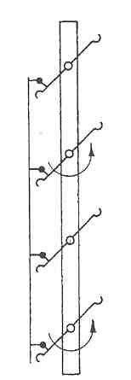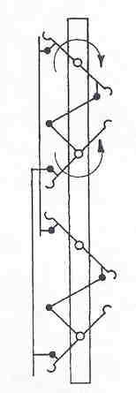
Figure 5.? - Parallel and Opposed Blade Dampers
    - The linkage drives the blades by rotating the shaft and is completely concealed in the damper frame. This arrangement keeps the linkage and pivot points out of the air stream, which can be an advantage from a pressure drop standpoint as well as a maintenance stand point if the air stream is dirty. However, if linkage maintenance is required, it is often more difficult due to the concealed location inside the frame.
  - The linkage drives the blades through a linkage that extends from blade to blade. In this arrangement, the shafts provide support and a pivot point, but generally do not transmit power from the actuator to the blades. The drive linkage is more accessible in this arrangement, but is also exposed to the air stream, which can add pressure drop and reduce the life of pivot points if the air stream is dirty.
In addition to the blade-oriented considerations discussed in the preceding paragraphs, the actual configuration of the blade itself should be considered when the damper is selected. There are two general blade designs available in the HVAC market currently.
    - Flat Plate - This configuration is the standard offering of most manufacturers and consists of a flat plate secured to the damper shaft, usually with some sort of bend or break folded to the length of the blade to ensure rigidity.
  - Airfoil - In this configuration, an extruded blade with a streamlined profile is used. An airfoil provides a rigid assembly that is resistant to flutter at high velocities and helps to ensure good blade seal compression. Thus, these dampers are often have a low damper leakage rating. The streamlined shape results in a significantly lower pressure drop as compared to the flat plate design; often by as much as half for identical damper geometries at identical flow rates. This lower pressure drop can be an advantage or a disadvantage depending upon how the damper is applied as will be seen in the next paragraph.
For most control applications, it is desirable to achieve some sort of linear relationship between damper position and damper flow. For example, the damper should reduce the flow through it by 50% when the damper has rotated 50% closed. To achieve this, it is necessary for the damper to have a significant pressure drop relative to the system that it serves. Figure 5.? illustrates the damper characteristic curves for a parallel blade damper at a variety of pressure drop ratios (α) where α is the ratio of system pressure drop to damper pressure drop. Opposed blade dampers have similar characteristic curves, but require less pressure drop to achieve the same linear control.
Ideally, the mechanical designer or controls contractor should have sized the dampers to achieve a nearly linear characteristic. Unfortunately, this step is often neglected and commissioning problems are often the result. Generally, the problems will fall into the following categories:
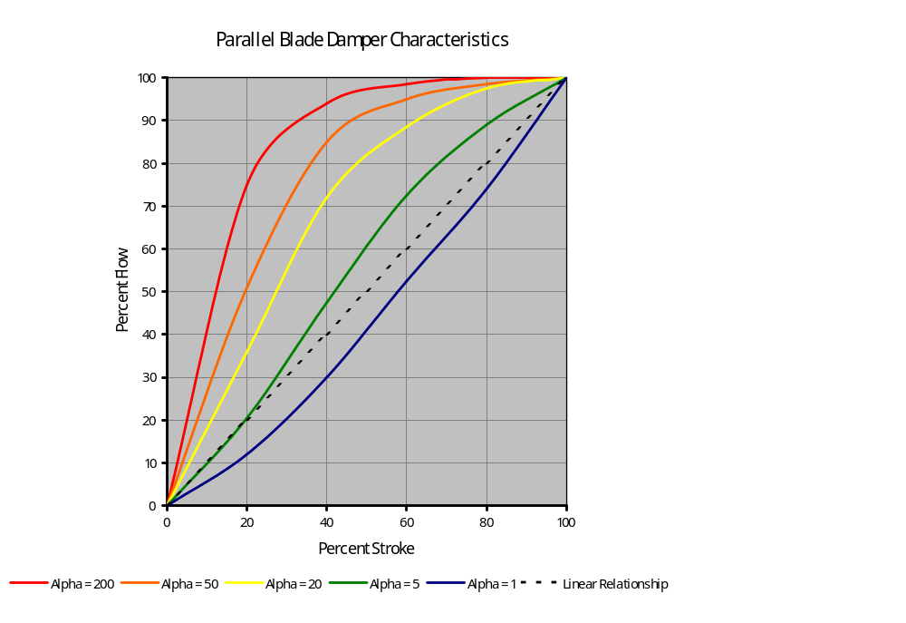
Figure 5.? - Parallel Blade Damper Characteristics - Alpha is the ratio of system pressure drop to damper pressure drop. An alpha of 200 means the damper pressure drop is 1/200 of the pressure drop of the entire system. As seen from the graph, a parallel blade damper needs to have a significant pressure drop across it relative to its system in order for the control to be nearly linear (50% stroke = 50% flow). The curves for opposed blade dampers are similar, but require less pressure drop to achieve the same linearity of control. (Developed from data in the ASHRAE Handbook of Fundamentals)
    - Poor mixing due to lack of velocity of the air streams. This topic was discussed in the preceding section of this chapter titled Mixing Functions.
  - Poor controllability due to a non-linear relationship between damper position and flow.
As a general rule, achieving a linear damper characteristic in most systems will require damper face velocities in the range of 2,000 to 2,500 fpm for flat plate type dampers and 2,500 to 3,000 fpm for airfoil type dampers. Based on this information a commissioning agent can quickly assess a system for potential mixing and economizer control problems by simply dividing the design flow rate by the damper face area. If the result is a velocity outside of the ranges indicated above, the commissioning agent should spend extra time on the testing and tuning of the economizer cycle.
As can be seen from the preceding discussion, the details of damper blade configuration can have a significant impact on the performance of the system the damper is installed in. Other details related to damper design, installation and construction with significant efficiency and/or other operational implications include:
    - Document the details to successfully achieve design intent - An amazing number of commissioning problems occur simply because the dampers are not installed correctly. There have been instances where multi-section parallel blade dampers were assembled with different blade rotations for each section; in other words, the blades in one section were horizontal and rotated downward as they closed, in the next section horizontal but rotating upward as they closed, in the next section the blades were vertical and rotated to the left, etc.. In other instances, it was virtually impossible to maintain actuators and linkages due to the installed configuration of the damper assembly. To avoid this sort of confusion, mixing damper configurations should be detailed in the design, preferably by the designer but as an alternative, by the control contractor, prior to installation. The detail should show configurations, number of sections, blade rotations, actuator locations, actuator linkage arrangements, blank-off panel locations and all other items required to install the dampers as required to achieve the design intent.
- Provide adequate access - Each control damper (not just fire and smoke dampers) should be provided with an adequately-sized access panel (or panels) that is unobstructed by surrounding systems, equipment, and building structure. This panel should be located so that when a technician is working through it, they can reach all damper components that are inside the duct, including linkage, bearings jamb seals and blade seals. (A 12" x 12" access panel in a 72" x 24" duct located 25 feet in the air over a motor control center and 3 feet upstream of the control damper is an access panel in name only.)
- Vertical blades need to have thrust bearings - Usually, but not always, the manufacturers catch this. Without them, the operation of the damper will wear out the jamb seals very quickly at a minimum. It is also possible that the blades will start to push into the degraded seals as they wear leading to other operation problems.
- Limit blade length - Blade lengths in excess of 48 inches are undesirable, especially for non-airfoil, non-extruded blades. At high velocities, the longer blades can flutter, and getting good blade seal compression as required to achieve the rated leakage rates can become a problem.
  - Select dampers that securely attach the shaft to the blade - There are a variety of techniques used to secure damper blades to shafts. Approaches vary from set screws to keyed arrangements. As a general rule the more positive connection provided between the damper blade and shaft by a slot and key or hexagonal shaft in a hexagonal hole is highly desirable. Less positive arrangements like set screws can often become loose over time, resulting in loss of damper functionality.
On occasion, the configuration of the air handling unit and the building make it desirable to combine some of the code-dictated fire and smoke isolation damper requirements with the economizer functions. This approach can have several advantages including:
    - Reduced cost due to multiple functions being served by one device.
- Reduced energy requirements due to the elimination of one pressure drop generating element from the air stream.
  - Reduced space requirements due to the need to only install one device.
As a result, some of the economizer damper assemblies are fire and smoke rated assemblies and the control signals to them must accommodate these functions in addition to the more conventional economizer functions. These applications deserve special attention from the commissioning agent to:
    - Ensure that all life safety control functions take precedence over environmental control functions, regardless of operating modes. For example, the smoke control cycle should have priority over the economizer cycle.
- Ensure that all life safety functions are implemented in a manner that does not threaten to harm the air handling system due to excessive positive or negative pressures or air hammer effects. Air hammer is presented in Section X.x Intake.
  - Ensure that the integrity of the fire and smoke damper assemblies are maintained during the installation and start-up process so that the agency listing of the dampers is not violated.
Additional information regarding fire and smoke dampers can be found in Chapter 6 of this guide in the section titled X.x.x. Fire Dampers, Smoke Dampers, And Combination Fire/Smoke Dampers.
Return to Overview Table of Contents

Actuators
The actuators used for HVAC control dampers generally fall into the following four categories which are discussed in detail in this section.
    - Piston actuators which use air pressure against a diaphragm and/or piston to move a shaft.
- Gear train actuators which use an electric motor with reduction gearing to rotate and output shaft that then moves the damper via crank arms on the actuator and damper shaft and an intervening linkage system.
- Gear train actuators which use an electric motor with reduction gearing arranged to mount with their output shaft concentric with the damper shaft, thereby eliminating a crank arm and linkage system.
  - Linear actuators which use an electric motor with reduction gearing to drive a jack screw which drives a crank arm on the damper shaft directly with out an intervening linkage system.
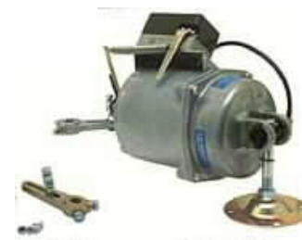

Figure 5.? - Typical Pneumatic Piston Actuator and Positioning Relay (Image courtesy of the Kele Associates web site)Piston Actuators
From a mechanical standpoint, piston actuators are generally the simplest, consisting of a housing, a piston and diaphragm, a spring, and a shaft through which force on the piston is transferred to the damper crank arm. They are typically actuated by pneumatic air pressure, with a maximum pressure of 30 psig or less in commercial applications. The spring constant determines the range over which the damper will actually stroke as the actuating pressure varies.
There are variations on the pneumatic actuator concept seen in the commercial HVAC market that are electrically powered. One fairly common design uses a small hydraulic pump to circulate oil from a reservoir to a chamber behind the piston. A variable size orifice controls how quickly this fluid can bleed back into the reservoir from the piston chamber. The orifice size is controlled by the control signal. As the size of the orifice is decreased, pressure builds up in the piston chamber and the piston extends. As the size of the orifice increases, pressure bleeds off and the actuator spring causes the actuator to retract. In another variation developed for remote sites with no control air source, a small self-contained compressor generates air pressure for use by a conventional pneumatic actuator. A fairly rare actuator design that may be seen on older projects uses a wax that has a high thermal coefficient of expansion and a heater. The heater output is varied by the control signal, which causes the wax to expand and move the piston.
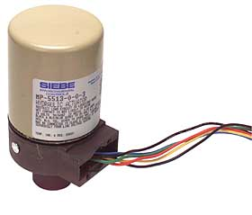
Figure 5.? - Hydraulic Type Piston Actuator (Image courtesy of the Kele Associates web site)Pneumatic piston actuators are often sequenced by selecting spring ranges appropriately so that one actuator strokes fully before the next actuator begins to stroke. However, forces generated by airflow acting on the damper blades in the HVAC system can feed back through the actuator shaft and work against the spring. The forces can shift the spring range significantly and significantly alter the sequencing, which can lead to energy waste.
For example, if a control system designer wanted to sequence a chilled water valve with the economizer dampers based on discharge temperature, the designer might specify a spring range of 5-8 psig for the economizer dampers with a normally closed outdoor air damper and a normally open return damper. To sequence the chilled water valve properly, they might specify an 8-13 psig range for the valve actuator with a normally closed valve. On paper, the outside air damper would be fully open by the time the signal reached 8 psig. At this point, the chilled water valve would start to open, thus guaranteeing the full utilization of free cooling using the outdoor air prior to using chilled water. However, if the forces on the damper blades shifted the spring range 1 or 2 psig, the chilled water valve might start opening before the outdoor air damper was fully open, thus using chilled water for cooling when it may have been possible to serve the load with outdoor air. To solve this problem, a device called a positive positioner or positioning relay is installed on the actuator.
The positive positioner is a position controller that has its own source of supply air. The device senses the position of the damper shaft with adjustments for start point and span. The positioner applies pressure to the actuator piston in order to get the piston to move as the control signal varies in the specified range. For example, if you wanted to be sure that a damper moved exactly over a 5-8 psig range, then you would install a positioning relay on the damper and set it to have a 5 psig starting point and a 3 psig span. In operation, when the control signal to the positioning relay reached 5 psig, the positioner would begin to apply main air pressure to the actuator piston until it detected shaft motion, even if it took 7 or 8 psig to make the damper start to move. The positioner would then proportionately move the damper shaft in response to an increase in control signal to ensure that the shaft was fully extended by the time the control signal reached 8 psig (the sum of the 5 psig start point plus the 3 psig span value).
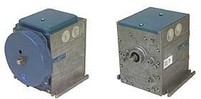

Figure 5.? Electric Gear Train Actuators (Image courtesy of the Johnson Controls website)Gear Train Actuators With Crank Arm Drives
These actuators represent older electronic technology in which a small single-phase motor (usually the shaded pole type) is used to drive a crank arm through a gear train. The gear train actuator can interface with a variety of signals including electric floating contact type controllers, variable resistance type controllers, two position signals, and common automation system outputs like 4-20 milliamps, 1-10 vdc or pulse width modulation. The type of interface is usually determined by an interface circuit board in the actuator or an interface module mounted to the actuator. Settings on the circuit boards or independent modules allow these actuators to be sequenced in a manner similar to that described for pneumatic actuators discussed in the piston actuator section. Most models can be equipped with a spring return feature to guarantee a fail-safe position on power failure.
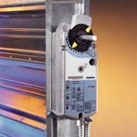

Figure 5.? - Electric Gear Train Actuator with Shaft Centerline Mounting (Image courtesy of the Siemens website)Gear Train Actuators With Shaft Concentric Drives
These actuators represent newer technology that developed in response to the widespread use of DDC control systems in the commercial buildings industry. The actuators avoid some of the potential linkage problems associated with piston actuators and gear train actuators driving through crank arms by mounting the actuator directly to the damper shaft, with the output torque applied directly to the shaft. Since the DDC market drove the development of these actuators, they can usually be interfaced directly to common DDC outputs. Sequencing with other actuators is usually accomplished by settings incorporated directly into the actuator. Most of these actuators are offered with spring return options for fail safe positioning on power failure.
Several manufacturers combine the actuator in the same housing as their VAV terminal unit controllers. This tends to make the installation costs lower with less start up problems as compared to systems that require that the VAV unit damper actuator be mounted and wired independently from the controller. But, it can increase the replacement cost when the unit fails since the entire assembly needs to be replaced, not just the failed component.
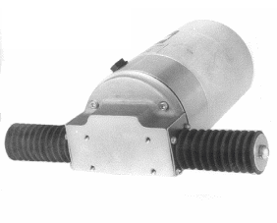

Figure 5.? - Linear Actuator (Image courtesy of the Tyco website)Linear Actuators
These actuators are more common in the industrial market than the commercial market but are sometimes found serving applications such as inlet guide vanes where a lot of actuating power is required. They typically consist of a jackshaft coupled with a motor of some sort and can accept most of the common output signals available from a DDC system.

Installation and Commissioning Issues
Generally, there are several commissioning issues related to installation of damper actuators as follows:
- Sizing - By reading the fine print on the damper leakage curves, one may discover that the preload torque required to achieve the leakage rate is higher than the torque required for actuation. Actuator selection, sizing, and set-up need to take the pre-load torque into consideration and the commissioning process should include verification that the field installation meets all applicable requirements.
Linkage Arrangement - Piston and linear type damper actuators need to be mounted a manner that allows the linear motion of the actuator shaft to be converted to rotation at the damper shaft. Usually this is accomplished via a linkage system that includes crank arms, extensions and swivels. Actuators should be mounted to maximize the linearity between actuator stroke and blade position and also maximize the torque available to the damper from the actuator through the damper stroke. The kinematics associated with the linkage arrangement are often not well understood by the field personnel installing the actuators, thus issues related to this can show up as a commissioning problem. Table 1 illustrates how the relationship between actuator stroke and damper bland position varies for a piston actuator.
Table 1: The effect of various piston actuator linkage arrangements on torque available at the damper shaft and on linearity between damper stroke and blade rotation
Mounting Arrangement | Percent Actuator Stroke at the Indicated Percent Blade Rotation |  |  |  |  | Maximum  Deviation from Linear  (Note 1) | Maximum Force Reduction  (Note 2)
Mounting Arrangement | 0%  (0°) | 25% | 50%  (45°) | 75% | 100%  (90°) | Maximum  Deviation from Linear  (Note 1) | Maximum Force Reduction  (Note 2)
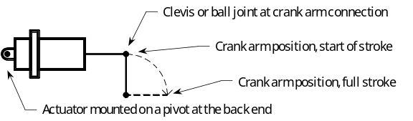 | 0% | 32% | 62% | 85% | 100% | +12% | 66% (occurs at full stroke; 100% available at start)
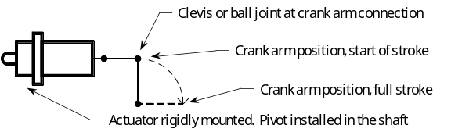 | 0% | 29% | 56% | 79% | 100% | +6% | 43% (occurs at full stroke; 100% available at start)
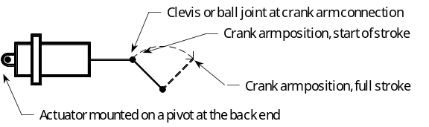 | 0% | 24% | 50% | 78% | 100% | -1%, +3% | 29% (occurs at the start and at full stroke, 100% available at 42%)
Note 1 A + indicates that the percentage of stroke leads the percentage of blade rotation.
Note 2 Only the actuator force applied perpendicular to the crank arm creates rotation and torque.
Similar considerations apply to linear actuators as well as gear train actuators that drive the damper via a crank arm and linkage. Actuators that concentric to the shaft and drive the damper shaft directly eliminate these issues by virtue of their mounting and drive arrangement.
Multiple section dampers with multiple actuators need to have identical actuators with identical linkage arrangements for all sections to make the characteristic for all of the sections consistent. Consistent damper section installations also make the performance of the entire assembly predictable based on the performance of one section. If the outdoor air damper and the return damper are multi-sectioned dampers controlled by the same signal, then all actuators for both sections should be identical with identical mounting arrangements for the same reason.
- Actuating Speed and Power - Most electric actuators have operating times that can vary from 30 to over 90 seconds to move through a full stroke. The slow speed is due to the small motors which must be geared down significantly to deliver the necessary torque required to actuate common HVAC devices. Pneumatic actuators, on the other hand, can have full stroke actuating times that are extremely fast and can deliver tremendous power due to the amplifying effect of air pressure over a large diaphragm area. For instance, a six inch diameter piston damper actuator with 20 psi air acting on it can easily deliver over 500 pounds of force at the shaft, even after compressing the damper spring. These characteristics can be advantages or disadvantages depending on the application.
- Rapid actuation speeds are desirable and even necessary if tight, reliable, and stable control is to be achieved on some systems. Usually, this is expensive and difficult to achieve electrically using commonly available technology in the HVAC industry. This item is worthy of review by the commissioning agent in the design phase. During start-up or in a retrocommissioning environment, changing from electric to pneumatic actuation may represent a viable solution to a start-up or operational problem related to system response time.
- Rapid actuation can be undesirable in cases where air or water hammer could be the result of a rapidly closing valve or damper. In situations where this is a possibility, the slower actuating times associated with electric actuators may be an advantage. If pneumatic actuators are installed at locations where they could generate air or water hammer, then it may be necessary to slow them down by using restrictors or metering valves in the circuit serving them. The commissioning agent needs to be aware of these issues and requirements and design functional test sequences to ensure that they are properly addressed.
Sequencing - As described earlier in this section, proper sequencing of actuators is often essential for efficient system operation, but cannot be solely guaranteed by the specifications and requirements of the contract documents. The functional testing performed during the commissioning process should include verification of proper sequencing under all operating modes. If sensors are installed at the proper locations in the system, trending can be used to allow the commissioning agent and operators to verify the persistence of the original sequencing. “Smart alarms” triggered by conditions that are not logical (a temperature rise across a heating coil that has its valve commanded closed for instance) may also be desirable.
From a historical perspective, pneumatic actuation and control systems where quite common in the commercial buildings industry. In the past decade, the wide acceptance and implementation of DDC control systems coupled with the development of shaft centerline drive type actuators have made electronic/electric actuation system more common in the commercial HVAC market. The electric/electronic actuators often can interface directly with the DDC system where as pneumatic actuators require some sort of signal converter. In addition, pneumatic actuators require a source of clean, dry air. On sites where this is not already available, the use of pneumatic actuation will require that this equipment be installed, operated and maintained. However, if a large operating torque is required and/or quick (less than a minute) actuation speed is necessary, then pneumatic actuation often represents the most cost effective and reliable option.
Return to Overview Table of Contents

Sensing Elements
Sensing elements perform critical tasks in ensuring proper economizer operation. The following paragraphs discuss sensing requirements particular to economizers. Refer to Chapter 2 - Guidelines for Control and Monitoring Points of this guide for general information regarding sensors used in air handling systems. Refer to Chapter 23 - Integrated Control Functions for additional information regarding the interaction of the economizer cycle with other building control cycles.

Temperature sensors
Selection and proper configuration of the temperature sensors used by the economizer cycle can have a very significant impact on its ability to perform as intended. Since even a well-designed mixing plenum can have some temperature stratification over its cross section, selecting and installing a temperature sensing system that averages the temperature across the entire cross section is an important aspect of the overall system design. There are a surprising number of projects encountered by commissioning agents where the first step in solving the economizer operating problems is the replacement of a single point sensor with an averaging sensor. The picture in Figure ? is from one such project. In this instance, the poor sensor configuration coupled with independent heat transfer element control loops was causing the system to do 10°F of unnecessary preheating.
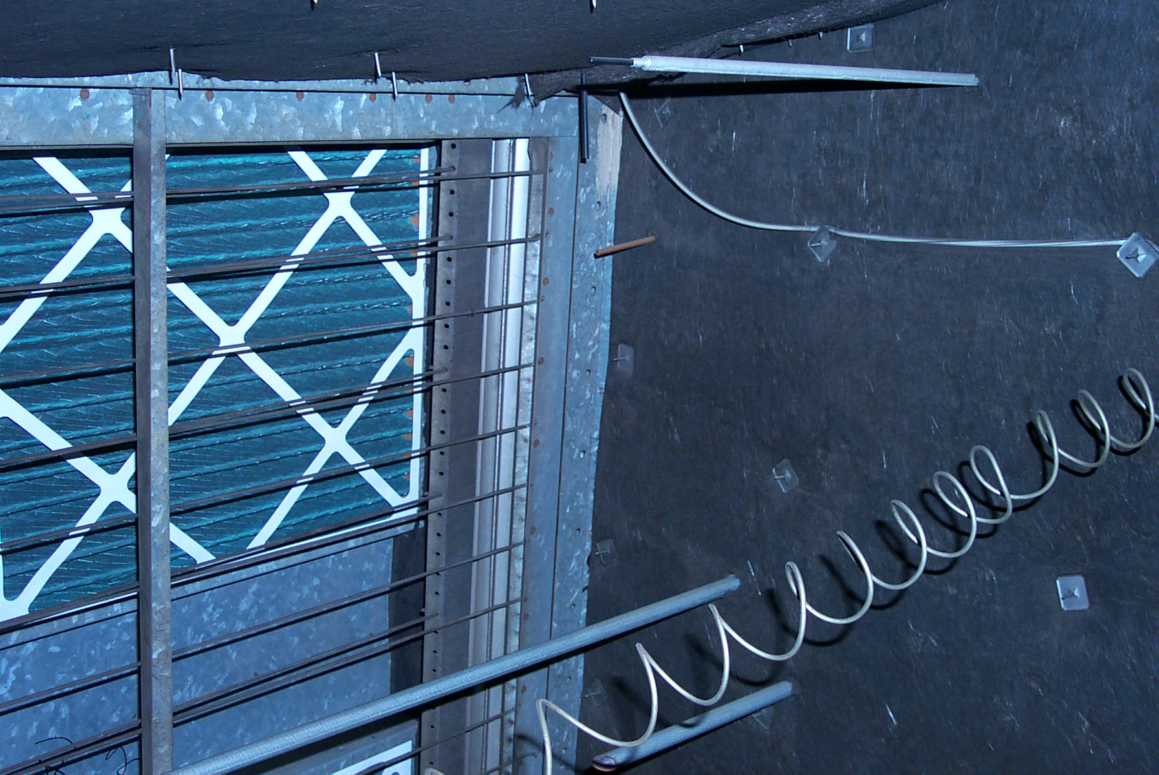
Figure ? - This single point sensor will have a difficult time averaging the temperature in this 6’ by 10’ mixing plenum. The mixed air sensor is in the red circle. The spiraled sensing element is the freezestat.
Specifying averaging sensors for economizer applications is a good first step, but it does not fully address the issues related to measuring temperatures in a mixed air plenum. The following items should also be considered:
1 The temperature that will ultimately be achieved by the complete mixing of a stratified air stream is a function of both the temperatures and the mass flow rates of the different temperature layers. The information sensed by averaging temperature elements is purely temperature and is effectively immune from the influences of mass flow rate. If the nominal face velocity over all portions of the averaging element is the same, then the average temperature indicated by the element is probably a reasonable measurement of the temperature that will be achieved in the air stream when it is completely mixed. However, if there are significant differences in the velocity over certain areas of the averaging element, then the average temperature indication sensed by the element may not accurately reflect this final mixed temperature. For example, when mixing a teaspoon of water at 200°F water with a gallon of 100°F, you would not expect the mixed temperature to be 150°F, even though this is the average of the two temperatures being mixed. Similar considerations apply to airstreams in mixing plenums.
If the true mixed temperature is higher than what the averaging element predicts, there may be comfort control problems since the system will not be delivering air at the required temperature. In some systems, the refrigeration equipment may operate to make up for this difference even though the system could achieve the required set point by using additional outdoor air in the economizer cycle, thereby negating some of the energy benefits of the cycle.
If the true mixed temperature is lower than the value indicated by the averaging element, then there could be problems with nuisance freezestat trips or coil failures. In some systems, the preheat coil will be activated to warm the air up to the required setting despite the fact that the system could achieve this temperature by using less outside air on the economizer cycle. Again, this wastes energy and negates some of the benefits of the cycle.
2 Stratification patterns and their associated velocity profiles can change with the operating point of the economizer. As the outdoor air and return air dampers modulate due to changes in set point, return, and outdoor air conditions, the temperature and velocity profile produced at the discharge of the mixed air plenum can change. Systems that mix well under some operating conditions may stratify under other conditions. Other systems may exhibit similar profiles regardless of the operating point. The Temperature Traverse Test and the High Turndown Ratio Test help identify temperature and flow patterns in the mixed air plenum and target solutions to related problems.
3 Large plenums may require multiple sensors to accurately reflect what is occurring in the plenum. Chapter 2 - Guidelines for Control and Monitoring Points, Section 2.5.1 Temperature discusses various approaches that can be used to accomplish average temperature from multiple sensors. The mixed air plenum stratification test included in this chapter can be used to determine the best configuration for the mixed air sensing elements under different operating conditions. It may be necessary to perform this test as part of new construction or retrocommissioning to optimize the configuration of the sensing elements so they provide repeatable, reliable information under all operating modes.
4 The mounting system used for the averaging elements should allow them to be easily reconfigured during the commissioning process if necessary. It should also support the sensing elements in a manner that allows them to accurately reflect the air stream conditions, free from other influences such as heat conduction from coils or other supporting equipment and radiant temperature effects from high temperature heat transfer elements like steam coils. Radiant temperature effects can be felt upstream as well as downstream of a heat transfer element. If you can stand at the mixed air sensor location with the palm of your hand facing a nearby high temperature coil, and can feel the radiant heat from the coil with your hand, then the element is probably being influenced by the coil.
Return to Overview Table of Contents

Freezestats
Freezestats are limit controls that are installed to protect the coils in an air handling system from being subjected to sub-freezing temperatures. Typically, they are arranged to shut down and lock out the system and a manual reset is required to resume normal operation. Contrary to popular opinion, the long sensing elements that they are provided with are not really averaging elements, even though they are visually similar. The sensing elements on most freezestats will respond to the coldest temperature seen by any one or two foot segment. This is desirable because it only takes a small stream of subfreezing air to freeze and rupture a tube in a coil.
Even though freezestats are not averaging elements, the same considerations outlined previously for the installation of averaging elements apply to the installation of sensors on freezestats. In fact, it is often desirable to string the freezestat element along with the mixed air temperature-averaging element so that they both are subjected to the same conditions. This allows the mixed air sensing element to reliably generate a pre-freezestat trip alarm that can be used to prevent an unscheduled outage.
The advent of DDC technology has lead to the development of software based freezestats. At first glance, this approach appears to offer some advantages in terms of lower installed cost and ease of operation. However, there can be some problems with this approach that can very quickly negate any of its benefits.
1 Usually the first cost savings is achieved by eliminating a device; i.e. the independent freezestat and its associated wiring to the starter. This means that the mixed air sensing element becomes the input to the freezestat control code and, in a sense, the mixed air sensor ends up trying to protect itself from its own failure.
2 Since the operation of the freezestat is now dependent on the operation of the DDC controller, a controller failure eliminates the freezestat protection. In some cases, a controller failure will not necessarily shut down the unit, so it is possible for a system to end up on line and operating without the intended protection in place.
3 Since the freezestat function in this approach is part of the controlling software, it is a part of the automation. Usually, the automated output that starts and stops the fan is wired to the “Auto” position of the “Hand-Off-Auto” selector switch on the fan. If the fan is placed in “Hand”, then the freezestat protection is eliminated from the circuit. An independent device can be wired into the common side of the selector switch so that it provides the necessary level of protection regardless of the selector switch position.
For these reasons, the best approach is to simply not use software based freezestat (or a software based safety of any type for that matter). If the software based system is employed on a project, it needs to be very carefully designed and commissioned to prevent the types of problems outlined above from occurring.
Most people think of a freezestat as providing protection for systems with water coils and would not consider installing one on a system that is equipped with direct expansion cooling and gas fired furnaces for heating. Generally, this is a reasonable assumption. But there have been instances where the plumbing and sprinkler piping in a building was frozen because such an air handling system remained in operation with an economizer that failed wide open during extreme weather over a weekend. Since there are no water coils to protect in this situation, the freezestat can be installed in the discharge duct where it is relatively immune from the effects of poor mixing and the related problems with nuisance freezestat trips, yet will provide protection against freezing the building plumbing and sprinkler piping.
Return to Overview Table of Contents

Enthalpy Switches and Sensors
There is a variety of equipment available to perform the enthalpy based economizer changeover function described previously under 8.5.5 Ambient Condition Interlocks.
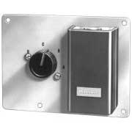
    - Figure ? - Typical two position enthalpy switch (Image courtesy of the Honeywell web site)Two Position Enthalpy Switches - Figure ? illustrates a typical two position enthalpy switch. The different scales on the switch correspond to different near-constant enthalpy states. By coordinating the scale selected with the requirements of the project, the switch can be used to provide a relatively low cost enthalpy based economizer change-over signal. The switches need to be mounted in an accessible location that subjects the sensing element to a free-flowing outdoor air stream but, at the same time, protects the element from exposure to water and direct and reflected sunlight. Typically, this means that the switch needs to be located in some portion of the outdoor air intake system where it is protected from water and sunlight but is exposed to the outdoor air conditions before the air is treated. This location can introduce some operating anomalies into the system due to lack of air flow when the unit is not in operation. For instance, minor air leakage back out of the unit from the building when the unit is off may cause the sensor to “think” the ambient conditions are suitable for cooling in the summer when they are not. When this unit first starts, it may try to operate on the 100% outdoor air cycle until the outdoor air flowing through the intake system can bring the local environment at the switch location into alignment with the actual outdoor conditions. This process usually happens fairly quickly, but it can be misleading to the commissioning agent during testing.
Protecting the enthalpy switch from atmospheric dust is also desirable, but usually difficult to accomplish because most recirculating systems do not filter the air until after the mixing plenum. For sites with a 100% outdoor air unit, the enthalpy switch can be protected by locating it downstream of the first set of filters but upstream of any heat transfer elements. This enthalpy signal can be used to pilot the other units on the site. For this approach to be successful, the unit where the switch is installed must be one that runs at all times that any of the other units piloted by the signal run. Without air moving across the filters and to the enthalpy switch, the signal from the switch will not necessarily reflect the ambient conditions.
As indicated previously, the switch settings correspond to a set of near-constant enthalpy lines on a psychrometric chart. It is important to remember that the lines are near-constant, not constant enthalpy lines when setting the switch. Many of the manufacturers include a small chart with the operating curves plotted on them with the installation literature included with the switch or actually print the chart on the switch housing. However, in the event that the installation instructions are not available, then it is fairly easy to construct the operating curves from a blank psychrometric chart and the tables included in the catalogs. Figure ? is an example of a chart constructed in this manner. Another option is to go to the internet and download the installation instructions since many manufacturers now provide this information in the form of .PDF files. For example, this link takes you to the location of the information for the switch depicted in the curves below; http://hbctechlit.honeywell.com/request.cfm?form=60-2301.
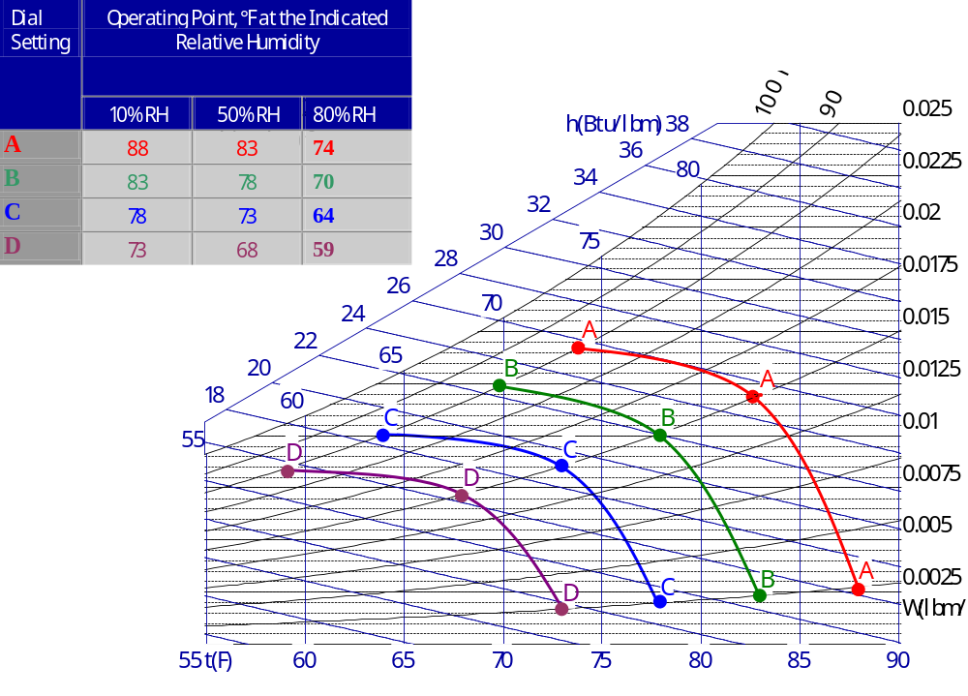
Figure ? - Enthalpy switch operating curves for a typical switch laid out on a psychrometric chart. If the installation information with the enthalpy switch operating curves is not available, operating curves can be drawn on a psychrometric chart using the information typically included in the supply catalog. Once you have made the curve for one type of switch, you can just keep a copy with your test equipment. For this set of curves, if the switch was set on scale D, then it would be in economizer mode for any condition left of the purple D line and at minimum outside air, out of the economizer mode, for any conditions to the right of the line.
Notice how the operating curves in Figure ? are really not constant enthalpy lines. They parallel the lines reasonably well for the upper portion, but fall away from running parallel, from the 50% point to their lower end. This curvature should be taken into consideration when determining the appropriate switch setting.
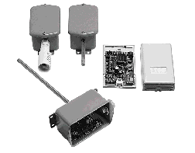
    - Figure ? - Enthalpy transmitters (Image courtesy of the HyCal web site)Enthalpy Transmitters Figure ? depicts an analog enthalpy transmitter. These units provide an analog output that is directly proportional to enthalpy. They can be wired as an input to the control system and the information they provide can be used for various enthalpy-based control decisions such as enabling or disabling the economizer mode. In general terms, the same mounting and servicing considerations apply to enthalpy transmitters as apply to enthalpy switches, although there are some designs available that are suited for direct or nearly direct exposure to the outdoor environment.
  - Enthalpy Calculations Because current control systems are computer based, they are generally capable of performing mathematical operations on their variables. This opens the door for calculating enthalpy using psychrometric equations contained in the ASHRAE Handbook of Fundamentals or the ASHRAE Brochure on Psychrometrics. Both of these documents contain psychrometric equations that can be solved for enthalpy if other parameters are known. Usually, the required inputs include dry bulb temperature, relative humidity or dew point, barometric pressure and elevation. For most applications, assuming a constant elevation and barometric pressure for the site will provide a satisfactory level of accuracy. As a result, the calculation can be reduced to one based on dry bulb temperature and humidity or dew point. For instance, outdoor air temperature and humidity are measured, then outdoor air enthalpy can be calculated and used for enthalpy based economizer interlocks assuming a return air enthalpy without any additional sensors. Space or return air temperature and humidity sensors can be used to calculate space or return air enthalpy, and economizer changeover strategies based on differential enthalpy can be implemented without additional sensors.
Return to Overview Table of Contents

Pressure sensors and switches
Pressure switches are also used in some systems to provide a safety interlock to prevent over or under pressurization of the duct or air handling unit casing in the event of a control failure. This is discussed in greater detail in the Control Strategies section of this chapter, under 8.5.4 - Static Pressure Switches.
While pressure sensors are not used directly by the economizer cycle, they are used in some control strategies to modulate the relief air dampers, which relates to the economizer function. This is discussed in greater detail earlier in this chapter under 8.4.5 Building Pressure Control Functions. When this approach is employed, building static pressure is measured and the system is arranged to modulate the relief dampers to maintain a slightly positive pressure in the building.
Minor variations in static pressure can cause interesting system problems if detected and processed by the control system. On one project, the minor building pressure changes associated with the employee entrance door opening and closing were driving the fan speed control loop for a 40,000 cfm air handling system into instability during shift changes. When the door opened, the building pressure dropped several hundredths of an inch. The change in building pressure was telegraphed to the supply duct static pressure transmitter, located in a branch duct near a diffuser near the door where it showed up as a change in duct static pressure of several hundreds of an inch (the set point was 0.5 inches w.c.) One or two door operations were not a problem, but when 40 or 50 employees left the building within a 10-15 minute interval, the pressure pulses drove the system into instability for several hours as the fan control system tried to follow them and the intertia of the large DWDI airfoil fan kept it from catching up. Filtering the input so that minor pressure pulses were not processed by the control system solved the problem.
One of the most important things to remember about measuring building static pressure is that very low differential pressure levels must be measured and controlled, typically less than on tenth of an inch water column. In most cases (but not all as will be discussed later), this pressure needs to be converted to some sort of force for an instrument to detect it and produce a signal as a result of it. The force needs to be great enough to move whatever mechanism is used to generate the signal in response to its variations magnitude. The impact of the mechanism activated by the force on the signal needs to be minimal. Frictional forces, springs, and other mechanical resistances imposed on the force generated by the measured signal in converting it to an output all work against generating a repeatable useable signal. For instance, if the break-away torque for a bearing is 1 foot-pound, then the shaft it serves will not move until the torque applied to it exceeds this value. If the force that was being applied to the shaft in normal use never ran much above this, then the mechanism would be fairly useless in transmitting the input force to the output shaft.
Instruments that measure the low differential pressures associated with building and air handling system static pressures typically use a diaphragm to actuate the signal producing mechanism. The differential pressure is applied across the diaphragm, causing it to deflect. The deflection is then used by a system of levers, pivots and springs or by discrete electronic components to generate an output.
To put this into some practical terms consider a 4-inch diameter diaphragm measuring a signal of one tenth of an inch water column. In this instrument, the force available from the diaphragm (assuming it is a perfect diaphragm with no mechanical losses of its own) to move the signal generating mechanism is less than one tenth of an ounce. A first class letter weighs approximately one ounce. That is not much force to move the levers, pivots and springs associated with this type of mechanism in a repeatable, reliable fashion for years in an environment that can see large temperature swings, dust, moisture, and vibration. Anything that can be done to improve this situation, like providing more force via a larger diaphragm or eliminating moving parts or increasing sensitivity to motion via electronics, or using some other approach to measuring pressure will result in an improved signal, a more robust system, and better control and efficiency. Thus a transmitter with a large diaphragm area will tend to be superior to a transmitter with a small diaphragm area, all other things being equal. Transmitters that are based on electronics rather than mechanics and kinematics will tend to be superior to those with many moving parts.
Another important point to remember is that even though the desired result for a building static pressure control system is a positive building pressure, in the real world operating environment, it may be beneficial to be able to detect and indicate both positive and negative pressures. Thus a sensor with a range of -0.1 inches w.c. to +0.1 inches w.c. might be better than a sensor with a range of 0 to +0.1 inches w.c.
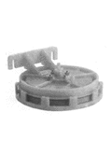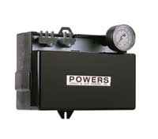
Figure ? - Typical pneumatic low differential pressure transmitter and associated receiver controller. The transmitter on the left serves as an input to the controller on the right. Because this type of controller “receives” its input from an external source rather than a built-in sensor, it is referred to as a “receiver controller” and can be used with a variety of input sensors rather than being segregated to one particular function. (Image courtesy of the Siemens web site)
There are a variety of technologies used to sense pressures in this range for building static pressure applications. Generally, the fall into the following categories:
1 Pneumatic differential pressure transmitters that sense via a diaphragm and create a force based on the sensed pressure - These transmitters typically use a diaphragm to sense and create a force based on the measured pressure. Figure ? illustrates a typical example along with a controller that it would be coupled to. The force generated by the diaphragm in the transmitter is used by a system of linkages, levers, and springs to generate a nominal 3-15 psig pneumatic signal that is proportional to the sensed pressure. This signal is used as an input to a controller that allows it to be compared to a set point and then generates an output. The output is used to modulate a final control element such as an actuator or variable speed drive as required to make the sensed pressure match the set point. In some cases, the pressure sensing function is combined with the control function in one package.
2 Electronic differential pressure transmitters sense via a diaphragm and create a force based on the sensed pressure - Electronic components use the force to generate a standard electronic output such as 2-10 vdc, 1-5 vdc, or 4-10 ma. The output is proportional to the measured pressure. As in the case of pneumatic transmitters, this signal is then used as an input to a controller that, in turn, generates a control output to modulate the system.
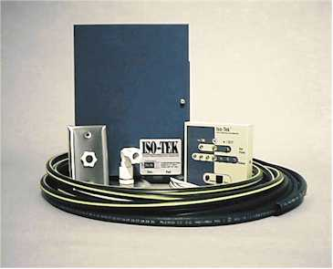
Figure ? - Typical flow based pressure sensor. This particular sensor is designed for monitoring hospital isolation room pressure, but the technology can be adapted to other low differential pressure applications. (Image courtesy of the TekAir web site)3 Electronic differential pressure transmitters that measure the velocity of a flow stream created by the pressure difference between to pressure zones as an indicator of pressure. If there is a pressure difference between two areas, then there will be flow between the two areas if there is an open flow path between them. This phenomenon is used to advantage by some transmitter technologies to measure pressure difference. Generally, these transmitters consist of a tube with a hot wire anemometer or similar thermal based flow measuring device located in it. One end of the tube is connected to the location where the desired pressure is to be monitored. The other end is connected to the reference pressure. If there is a difference in pressure between the two ends of the tubes, then air flows through the tubes. This flow is detected and measured by the hot wire anemometer and an output in terms of pressure is generated based on the flow rate. The output is typically a standard electronic output such as 2-10 vdc, 1-5 vdc, or 4-10 ma and this signal is then used as an input to a controller that, in turn, generates a control output to modulate the system. Figure ? illustrates a typical transmitter of this type.
The following paragraphs will discuss these approaches in greater detail.
Return to Overview Table of Contents

Pneumatic Pressure Transmitters
Though less common due to the advent of DDC technology, there are still numerous existing systems that use pneumatic pressure transmitters to provide inputs to pneumatic controllers for building static pressure control. While the systems can be made to function, the resolution and repeatability associated with modern electronic-based transmitters will provide a better solution on new projects, thus a pneumatic based system should not be the system of choice for this application in new construction if at all possible. However, there are often situations where commissioning agents find themselves confronted with making this approach work reliably and repeatedly. In this case, the following issues should be considered and evaluated.
1 Differential Pressure Measurement Capabilities - Unfortunately, many of the transmitters available in the commercial pneumatic product lines are not very well suited for measuring the low pressure differentials typically associated with building static pressure control.
- The available ranges are often two to four times what might be desired.
- The stated accuracy of the transmitter is often a significant percentage of or even equal to the signal that must be measured.
- Diaphragm areas tend to be small and thus the forces produces to actuate the measurement mechanism.
- The measurement mechanisms tend to be mechanical with the associated frictional losses and hysteresis problems.
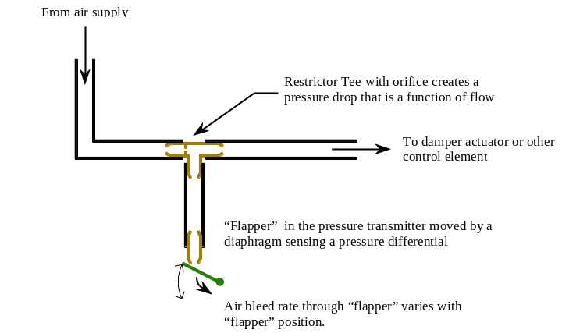
Figure ? - One pipe pneumatic transmitter operation. A one pipe transmitter creates its signal by varying the flow of control air through a fixed orifice. The sensing mechanism is arranged to continuously bleed air from the down-stream side of the orifice with the bleed rate controlled by the process variable. As a result, the pressure downstream of the tee will vary with the process variable. The term “one pipe” comes from the fact that the sensing element or transmitter has only one pneumatic line connected to it. A two pipe transmitter has a supply line connected to it as well as a signal line and does not continuously bleed air to generate a signal. Instead, it uses a feedback mechanism to add or remove air from the signal line so that the pressure in the signal line is proportional to the variable sensed.2 Signal Transmitting Technology - Transmitting the pneumatic signal is further complicated by the fact that most of the commercial grade units use one-pipe technology. This approach is illustrated in Figure ? and is prone to the following problems:
- The tubing between the restrictor tee and the transmitter can become a source of pressure drop that affects the signal from the device but is not accounted for in its calibration. If a long run of tubing is installed between the transmitter and the restrictor tee, the calibration may not match the factory specifications. Most manufacturers state a length of run limitation for their transmitters to address this issue. It is important that this length is the length of the tubing run, which may be different than the distance between the transmitter and the restrictor tee on a plan view of the building.
- Most restrictor tees include a foam filter element to protect the very tiny hole that forms the orifice in the tee from being obstructed with grit. As this filter becomes dirty, it also adds an un-calibrated pressure drop to the system. Most manufacturers recommend changing restrictor tees out annually (or more often) in order to address this issue. However, most building maintenance staffs are unaware of this requirement and may even be unaware of the presence of restrictor tees in the first place. So, when faced with commissioning or recommissioning an existing system that uses this technology, a good first step is to perform the restrictor tee replacement recommended in addition to checking calibration of the instruments.
- Most commercial one-pipe transmitters are factory calibrated and cannot be calibrated in the field. (If you decide to try it you will probably wish you hadn’t. Barely detectable movements of the zero and span screws can cause output changes of 10% or more.)
All of these issues with pneumatic transmitters can result in an input system that does not provide reliable, repeatable data for use by the control system. Fortunately, there are several options available that can help address these problems.
1 Install a Process Grade Transmitter - Pneumatic pressure transmitters are still available in the product lines of many process control manufacturers. Often, the available ranges are not much better than the ranges available in the commercial product lines, but the overall accuracy can be significantly better (0.5% of full scale vs. 5% of full scale). Some product lines include a device called “draft pressure transmitters” which were originally designed for boiler combustion control systems. These devices can have spans as small as 0.25 inches w.c. with accuracies of 2% of full scale. This is a significant improvement over any of the available commercial products. Generally, these improvements are achieved by using larger diaphragm areas and high precision mechanisms with better bearing systems and lower resistance to movement and hysteresis. In addition, the process grade instruments use two-pipe technology, thereby eliminating all of the problems associated with one pipe technology.
The down side is that the process grade products are much more expensive than the commercial products, often by a factor of 10 or more ($150 vs. $1,500). This cost can often be very easily justified in light of the energy and comfort benefits gained by making a non-functioning system function as intended and the durability and improved service life that can be expected. However, the cost premium can come as quite a shock to an Owner who is unfamiliar with the problem and the requirements of the solution. The other problem with using process grade transmitters is lack of familiarity with the product in the commercial HVAC marketplace. Many times, this can be easily addressed by training, a primary component of the commissioning process. But, in buildings where the operating staff undergoes frequent changes or where the maintenance is handled by a service contract, this lack of familiarity can be a significant issue.
2 Install an Electronic Sensor and Convert the Signal to Pneumatic for Use by the Pneumatic Controller - While slightly cumbersome technically, this approach can provide a significant improvement in the input signal quality to an existing pneumatic control system in some cases. The input signal improvements are accomplished using readily available commercial products, combining a standard low range, high accuracy electronic pressure transmitter with an electronic to pneumatic signal converter. The accuracy, repeatability and hysteresis characteristics of the signal converter are key to achieving good overall accuracy with this approach. A low quality converter can quickly erode away any benefits gained in using an electronic sensor. The most significant disadvantage of this approach is that the existing pneumatic tubing from the transmitter to the controller location must be replaced with wire to accommodate the electronic signal or wiring must be run to the transmitter location to power the transmitter and electronic to pneumatic signal converter.
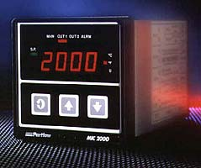
Figure ? - Typical stand-alone process controller. The controller pictured here is typical of the single loop stand alone controllers manufactured by many process control companies. While it may appear somewhat intimidating to the uninitiated, the operation is usually very well documented in the manuals. If you can work a VCR remote, you can probably master one of these devices (Image courtesy of the Partlow web site)3 Replace the Pneumatic Controller and Sensor with an Electronic Controller and Sensor and Convert the Output to a Pneumatic Signal - For a relatively modest incremental cost increase over option 2, it is often possible to replace the entire pneumatic control system through the controller with an electronic system using a stand-alone process controller (see Figure ?). This approach allows all of the advantages typically associated with DDC technology but can be easily interfaced to the existing pneumatic actuation system via a standard, readily available electronic to pneumatic converter. In installations where the existing pneumatic signal is being converted to an electronic signal for interface to a variable speed drive, this approach can actually simplify the system since the controller will most likely be able to interface to the drive without a signal converter. The disadvantage to this approach is that wiring must be installed to replace the pneumatic tubing that provides the input signal in an all-pneumatic system. Once installed, the system will generally provide much better performance and can be readily adapted to DDC technology and controllers if and when the rest of the control system is upgraded.
Return to Overview Table of Contents

Electronic Force Based Differential Pressure Transmitters
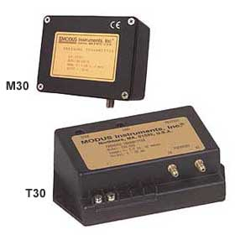
Figure ? - Typical force based differential pressure transmitter. These particular transmitters use a capacitance type pressure cell. (Picture courtesy of the Kele web site)In principle, electronic force based transmitters function in a very similar manner to the pneumatic transmitters discussed in the preceding paragraphs. The difference is that the motion of the diaphragm (created by the pressure difference across it) is converted to an electronic signal rather than a pneumatic signal. However electronic components are used to make the signal conversion rather than a mechanical system of levers, pivots and springs. This takes advantage of the inherent sensitivity of electronics and their lack of moving parts to provide a more repeatable signal with higher resolution. Techniques for making generating the electronic signal typically involve using the diaphragm to cause some change in capacitance or resistance with is then amplified and conditioned by an electronic circuit to provide a standard output. It is not unusual for the diaphragm to function as one plate of the capacitor in capacitance-based instruments. In other instruments, strain gauges attached to the diaphragm generate a variable resistance as the diaphragm flexes. There are products where the diaphragm is actually an etched out part of the semiconductor chip upon which the integrated circuit for the sensor is fabricated.
All of these factors combine to create sensors that provide more robust performance as compared to pneumatic products in the same price range. However, even better performance in terms of resolution, can be achieved with the flow based pressure sensors discussed in the next section.
Return to Overview Table of Contents

Electronic Flow Based Differential Pressure Transmitters
As indicated previously, transmitters in this class indicate a pressure difference based on and input generated from the flow created by that pressure difference. The technology was originally developed to provide monitoring and control for hospital isolation rooms where very low-pressure differentials must be monitored, maintained, and alarmed if infections control requirements are to be met. The technology has also found application in application specific controllers targeted at laboratory fume hood control systems. Both systems can be adapted for use to monitor and control low level static pressures associated with other HVAC processes such as building static pressure control. These transmitters are generally capable of resolving pressures as slow as one ten-thousandth of an inch water column and can be set up for a full scale range of several hundredths of an inch with an accuracy of +2% of that range, making them ideal for this application. This performance comes with a bit of a cost penalty relative to the other electronic technologies; typically by a factor of 2 or 3 ($150 - $200 vs. $600-$900). However, in the context of the task to be performed and the benefits in terms of energy and comfort that can be attained by a persistent, successful implementation of the strategy, the benefits almost always outweigh the costs.
Return to Overview Table of Contents

Transmitter Installation and Sensing Line Considerations
Regardless of how the static pressure signals are measured, the method used to extend the sensing connections from the transmitter to the location sensed as well as the method used to terminate the tubing ends at the sensing location can have significant impacts on the system’s ability to perform. The issues to be considered are as follows.
1 Transmitters are More than Signal Converters - One of the functions that a transmitter performs is to convert a low grade, noise susceptible, non-standard signal such as the resistance or capacitance variation in a differential pressure sensing element to a higher grade, industry standard, noise immune signal such as a 4-20 ma current loop. This function:
- Allows a nearly infinite variety of process sensors to be readily interfaced to a few industry standard inputs.
- Protects the relatively low level (e.g. milivolt, micro-ohm, micro-farad, hundredths of an inch water column) sensor signal from the effects of electrical noise between the sensing location and the input location.
- Allows the signal to be transmitted over large distances without degradation due to wiring resistance.
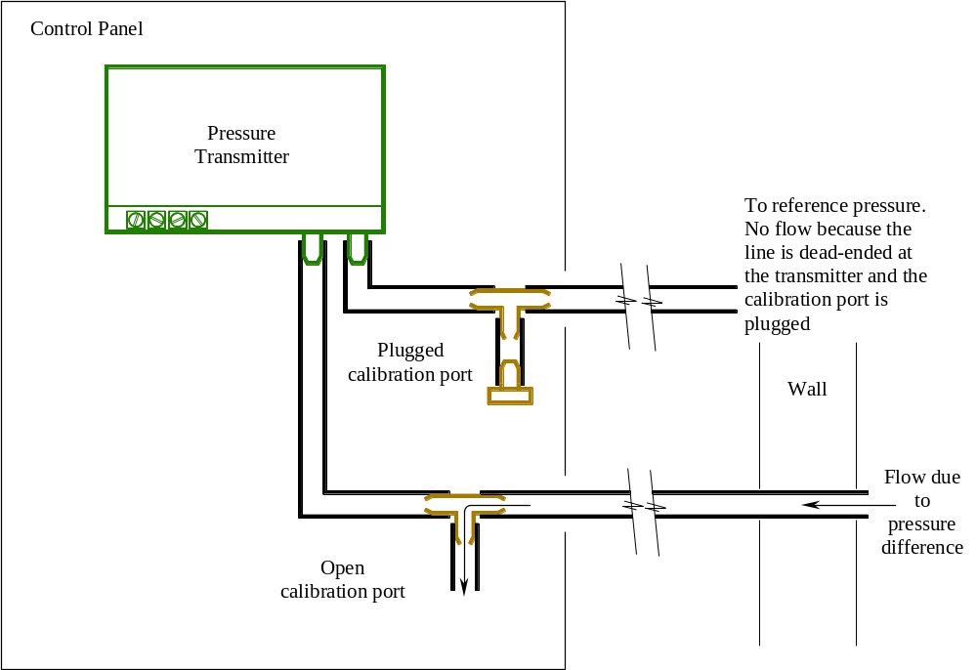
Figure ? - The impact of an open calibration port on the input signal measured by a pressure transmitter located at the control panel location instead of at the point where the signal is measured. Many times, pressure transmitters are installed with a plugged tee on their input sensing lines where they connect to the transmitter to allow a separate meter to be connected in parallel with the inputs for calibration purposes. This figure illustrates what happens to the input signal to the transmitter if one of these ports is unintentionally left open in a situation where the transmitter is located at the control panel rather than at the location where the pressure is being measured. At a minimum, the open connection at the equipment room tends to reference the transmitter to that location rather than to the desired point. If there is a significant pressure difference between the two locations, then air will flow through the input tube, creating a false reading due to the pressure drops associated with flow through the tube. While the magnitude of the pressure drop may not be significant in absolute terms, it can be a significant factor when the pressure being measured is only several hundredths of an inch w.c. in the first place. Leaks in the tubing due to nicks or loose fittings can create a similar situation.
It is not uncommon to find transmitters located in the auxiliary panel immediately adjacent to the controller and hundreds of feet from the location of the sensor. While desirable from a maintenance standpoint since all of the transmitters are easily accessed for calibration or replacement when necessary, it defeats some of the most significant benefits of having a transmitter in the first place; to protect the sensor signal from noise and degradation. In the case of the transmitters used for building static pressure monitoring and control, locating the transmitter next to the control panel and extending the tubing to the sensing location means that the very low signals associated with building pressurization (usually no more than ten hundreds of an inch) are sent through hundreds of feet of tubing. At first glance, this distance may not seem like much of an issue, since the tubing does not carry flow (except for a few fractions of a second when there is a pressure change). The pneumatic tubing is dead ended at the transmitter location and therefore is immune to the effects of pressure drop due to flow as a matter of normal operation. However, the pressure drop is not immune to the effect of flow created by leakage due to branch connections that were un-intentionally left open, loose fittings, and nicks introduced during the construction process and subsequent life of the building. Figure ? illustrates the impact of a calibration port that was left open to the equipment room environment. Other unintended openings in the sensing tubing runs can have a similar effect. Even a minor leak can have the effect of neutralizing the signal from the intended location and referencing it to a different pressure condition.
When properly installed and applied, the electronic output signals from pressure transmitters are relatively immune to the effects of distance and the conditions in the spaces they traverse. Thus, the best input system is provided by locating building static pressure sensors (as well as other sensing elements) near the signal they are measuring and allowing them to act as signal transmitters as well as signal converters. Additional information regarding signal transmitters and their impacts on input accuracy can be found in Chapter 2 - Guide for the Selection and Installation of Control and Monitoring Points.
2 A Single Sensing Tube Connecting the Pressure Sensor Input to Multiple Spaces at Different Pressures does not Provide an Input that is the Average of the Different Space Pressures - Often, it is desirable to measure several different building pressures and use the average value as an input or indication of building static pressure. Many times, an effort is made to minimize the cost to accomplish this by installing one static pressure sensor and then connecting its reference ports to multiple spaces. Unfortunately, this results in a situation very similar to what is depicted in Figure ? above. The input created is some function of the different space pressures, but it does not adequately represent the mathematical average. The resulting pressure input is the result of a complex set of flow patterns and relationships set up in the tubing system by the pressure differences in the rooms that the tube is connected to and the pressure drops through the tubing system due to the flows created by the pressure differences. While it may be possible to make the system perform reasonably well based on this information, the signal is not equivalent to the average pressure or any actual pressure but as a potentially non-linear pressure coefficient that is a function of the various pressures.
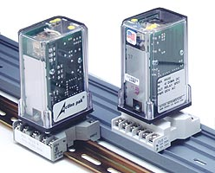
Figure ? - Typical math function type signal conditioner. (Image courtesy of the Action Instruments web site)Approaches that would provide a true indication of average pressure value include:
- Provide a transmitter in each space wired to an individual input and use the system software to average the signals. This approach makes the most information available to the operators and the allows greatest flexibility since the software can be modified to do other things besides average the inputs, like select the highest or lowest if necessary. However, the approach requires an input for each space referenced.
- Provide a transmitter in each space wired to an independent signal-conditioning module that provides an output that is an average of its inputs (See Figure ? for an example). This approach minimizes the number of inputs required but is less flexible because it provides less data and the averaging calculation is fixed in hardware rather than software.
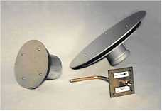
Figure ? - Typical static pressure sensing probes. (Image courtesy of the Tek-Air web site)3 The Technique Used to Terminate the Static Pressure Reference Sensing Lines can Impact the Signal Measurement - The ends of the sensing lines used to measure static pressures need to be located and arranged so they are immune to the effects of wind, space air motion, duct air flow, and other velocity pressure influences. A 5 mile per hour breeze has a velocity pressure of 0.01 inches w.c. associated with it. This error could be a significant portion of the value registered by a building static pressure probe.
A well-designed outdoor air static pressure probe will provide a reference point that is relatively immune to this type of effect if properly located. Location is an important factor because a probe that is located in a low pressure zone created by the motion of the air around the building will still provide a bad reference and cause operational problems. Finding a good location for a static probe can be tricky and takes some time during the commissioning process. The benefits are usually worth in the effort in terms of more stable system performance.
There are a wide variety of probes manufactured by different companies targeted at measuring different static pressures including outdoor air static, duct static and space static. Figure ?. illustrates several designs by one manufacturer. In general, the devices make use of baffles and pulsation dampening chambers to eliminate some of the spurious effects associated with air motion.
4 Provisions that Filter Out Minor, Random, Static Pressure Variations can Often Provide Significant Performance Improvements - Many of the electronic pressure sensing technologies used to measure building static pressure are capable of detecting and reporting very small and rapid pressure changes. This can be both a good thing and a bad thing for the commissioning agent, as can be seen from the previous side bar. Detecting and attempting to respond to the minor variations in building static pressure associated with a door opening every once-in-a-while may not be necessary and could create more problems than it solves. On the other hand, responding to a small but sustained loss of building pressure created by a door that is blocked open for some reason, might be highly desirable in terms of controlling building pressure relationships and comfort.
Because the static pressure signals measured in air handling applications are relatively small and easily influenced by other factors such as air motion, they tend to be very “noisy” when viewed in terms of the desired average value. There are a variety of ways to mitigate this signal noise. Implementing one of the following techniques to correct a noisy signal identified in a functional test may yield very significant improvements in the performance of the system.
- Many modern DDC control system can apply a filtering factor directly to any analog input on the system. If available, this approach is probably the easiest to implement.
- If a standard filtering factor is not available, most systems will allow the user to write some software that averages the input based on a moving window of some sort. The output of this calculation can then be used as the actual input to the control or monitoring process.
- Resistor/capacitor and resistor/inductor networks can be wired across the input connections on most system to stabilize a noisy signal. The companies that manufacture the signal conditioning modules shown in Figure ? above also typically manufacture modules that will provide this function as a packaged solution.
- Simply creating a pulsation chamber with a restricted inlet in the input sensing lines to the transmitter can often solve a noisy signal problem. Any pressure change that occurs must first change the pressure in the entire volume of the pulsation chamber before it actually impacts the reading at the transmitter. The restriction in the input prevents minor pulses from affecting the chamber pressure significantly but will allow a sustained pressure change to eventually be reflected in the chamber, and thus, at the input to the transmitter.
Return to Overview Table of Contents

Flow Sensors
In economizer systems, flow sensors are typically encountered in the minimum outdoor airflow regulation portion of the system. The set points of the loops controlling outdoor air flow may be optimized by a variety of factors including CO₂ level, schedule, occupancy, etc., but the primary control loop is typically based on measuring and controlling for a flow. As a result, verification of flow measurements and flow sensing equipment often must be accomplished as a part of testing the operation and performance of the mixing section of an air handling system.
A general discussion of flow measurement can be found in Chapter 2 - Guidelines for Control and Monitoring Points. In addition, since many flow measurements are based on velocity pressures, many of the guidelines in the preceding section on static pressure measurement also apply. The following additional points should be considered when commissioning flow measurement systems for minimum outdoor air control.
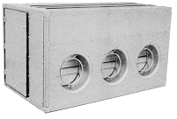
Figure ? - Typical packaged outdoor air measurement and control assembly. The round devices on the plenum are air control valves that include an averaging type flow measurement ring as a part of the assembly. (Image courtesy of the Trane web site)1 Obtaining a Uniform Velocity Profile Under All Operating Conditions is Critical to Ensuring Good Control - This point is true in any flow measurement application, but is often neglected in the sensing arrangements used for measuring the minimum outdoor air flow into a unit. In addition, the close-coupled configuration of typical intake systems can often make it difficult to find the physical space to meet the typical rules associated with establishing a uniform velocity profile. Finally, the modulating operation of the maximum outdoor air dampers can have a variable impact on the performance of the minimum outdoor air flow sensing and control system depending on the current operating point of the economizer.
Some manufacturers now offer packaged products that incorporate flow measuring and control elements to accurately measure and control outdoor air flow using technology similar to what is applied on a VAV terminal unit. Figure ? is one example of this type of product.
2 The Pressure Relationships Between the Outside, the Mixing Plenum, and the Return System Play a Critical Role in System Performance - The flow through the minimum outdoor air flow control system is driven by the pressure difference that exists between the outdoors and the mixing plenum. On economizer systems, this pressure can vary as a function of the position of the economizer dampers, especially if they have not been sized for linear performance. If the system is a VAV system, then the pressure relationship can also vary with system flow rate. All of these issues need to be considered when selecting and commissioning the flow control system and its sensing elements. If the pressure required to drive the necessary flow through the sensing system is not sufficient, then the system will not be able to achieve the required flow rate, no matter what its nameplate rating is.
3 When the System is Operating on the Economizer Cycle at a Flow Rate Above its Minimum Outdoor Air Flow Requirement, Then the Operation of the Minimum Outdoor Air Flow Control System May Be Irrelevant - Operation of the minimum outdoor air flow measurement and control system is critical for controlling indoor air quality when the system is operating in the minimum outdoor air mode. The system must be arranged and controlled in a manner that prevents it from delivering less than the minimum outdoor airflow requirement. Usually, this occurs during extreme winter and summer weather.
If the system is using significant amounts of outdoor air for an economizer cycle, then the performance of the minimum outdoor air flow control system may not be relevant since the system is bringing in outdoor air in excess of the minimum flow requirements. Thus, the functional testing of this system can often be targeted at ensuring its performance during extreme conditions with little if any attention paid to its performance under the economizer cycle, unless there is some requirement for documenting the minimum outdoor air flow at all times.
Return to Overview Table of Contents

Blank-off plates
Most control dampers (like control valves) will be smaller than the duct they are in. Usually, this means that blank-off plates are installed to make up the difference. Two important factors need to be considered with regard to blank-off plates.
    - The location and configuration of the blank-off plate/damper assembly needs to promote mixing.
  - The pressure loss associated with the reduced damper area relative to the duct need to be taken into account in the sizing of the fan system. Some manufacturers include a factor for this in their pressure drop tables. Others allow the designer to determine the impact through an independent assessment.
Blank-off plates are also used in troubleshooting and retrocommissioning applications to deactivate portions of an existing, oversized damper to improve its performance characteristics. Disconnecting blade linkages to deactivate the blades and then screwing the blades in the closed position can achieve a similar effect. These procedures will be discussed in more detail in the following section.
Return to Overview Table of Contents

Air Blenders and Baffle Plates
In a mixing plenum with dampers that has been optimized to promote mixing, there will be some distance required for mixing to occur. As a general rule, there should be at least 3 or 4 feet between the downstream side of the mixing dampers and the location in the unit where complete mixing needs to have occurred (usually the first coil in the unit). There are a variety of ways to accomplish full mixing including:
    - Use the space required for filter banks and operator access to provide the necessary distance for mixing. In some instance, the filters can help to promote the mixing process due to the turbulence they create as the air flows through them and because they tend to promote a uniform velocity profile.
  - Locate the mixing box some distance from the air handling unit so there is duct work and, ideally, an elbow or two between the outside and return dampers and the components of the air handler.
There are many instances where there simply is not enough space allocated in the mechanical room to provide the distance necessary for good mixing to occur. In these instances, air blenders or baffle plates can provide a mechanism to enhance the mixing of the outside and return air flow in a shorter distance.
Air blenders are manufactured devices that are designed to promote mixing and eliminate stratification in very short distances. A well-designed mixing box with properly sized and arranged dampers and sufficient distance for mixing can often achieve a 3-5°F spread between the warmest and coldest spot in the plenum discharge. For many HVAC applications, this level of mixing will be satisfactory. But if more uniform temperatures are required, or the available space does not provide sufficient distance for mixing, air blenders can be applied to meet or possibly exceed this level of performance. On existing projects with stratification problems, air blenders can be retrofitted into the system as a corrective measure, assuming the system has sufficient static pressure capability to handle the added pressure loss.
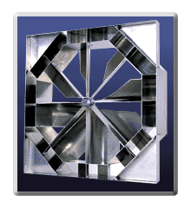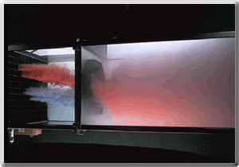
Figure ? - Typical air blender. The picture to the left is an air blender module. The picture to the right is a similar module under test, demonstrating its ability to mix the two colored air streams. (Pictures courtesy of the Blender Products web site.)
On many occasions, commissioning agents, Owners, facilities engineers and other people concerned with system operations find themselves faced with a system that has severe stratification problems that cause nuisance freezestat trips (or worse) without the luxury of time or budget necessary to allow air blenders to be retrofitted into the system. In these situations, baffle plates can offer a low cost, easily improvised, field solution to stratification problems that would otherwise be handled with air blenders. Baffle plates are sheet metal baffles installed downstream of the mixing dampers in an arrangement that will cause the airflow through the unit to change direction and/or induce turbulence. These directional changes can often improve the mixed condition enough to eliminate the problem.
Baffle plates can be solid metal or perforated metal. The solid metal plates rely on directional changes to achieve the desired effect. The perforated metal plates cause some directional changes but also induce mixing due to the jet effect created by the air that passes through the holes in the plate. If sufficient free area is maintained so that the average velocity in the airflow path is below 800-1,000 feet per minute, baffle plates can produce a significant improvement with little increase in pressure drop.
Baffle plates can be especially effective when combined with other improvements like adding a mixed air low limit cycle and improving the performance of oversized mixing dampers by disabling damper blades. Appling baffle plates will be discussed in greater detail in the next section.
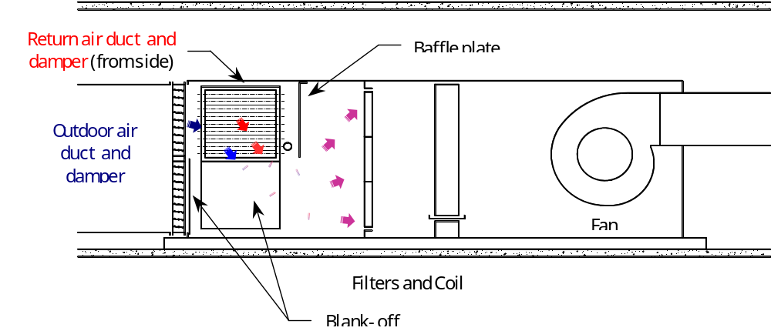
Figure ? - Blank-off plates and baffle plates help alleviate a stratification problem. On this VAV unit, a stratification problem that was causing nuisance freezestat trips when outdoor air temperatures dropped below the mid 20°’s F was solved by blanking off one of two damper sections on the outdoor air and return air dampers and adding a baffle plate ahead of the filter bank. Blanking off one damper section increased the velocity through the remaining section, improving its linearity and adding momentum to the air stream, which promoted mixing. The baffle plate forced the air to turn and then re-expand at the filter bank, which further improved the mixing. The velocities through the area below the baffle plate were still well below 1,000 fpm, thus little additional pressure drop was added. Increasing the damper velocity through the blank-off plates added some pressure drop, but running the motor into its service factor on design days and changing the filters slightly sooner accommodated this. The VAV system spent very little time at full capacity, thus running into the service factor had minimal impact on the motor life expectancy.
Return to Overview Table of Contents

Verification Checks and CPTL References
The Economizer Evaluation Checklist included previously provides a good overall verification check technique that can be used in the field or during design review. In addition, the following functional tests included in the CTPL contain verification checks that can be applied to economizer systems.
Economizer Procedure
Click on the button to go to a GENERAL COMMISSIONING PROCEDURE FOR ECONOMIZERS as prepared for the Pacific Gas & Electric Company, Customer Energy Management Non-Residential New Construction Program.

Click on the button to go Other CPTL Procedures with Economizer Verification Checks. (Insert as many buttons as are required after researching the latest version of the CPTL)
Link to ?????

Click on the button to go Other CPTL Procedures with Economizer Verification Checks. (Insert as many buttons as are required after researching the latest version of the CPTL)
Link to ?????
Return to Overview Table of Contents

Functional Tests
The CTPL procedures linked to the buttons in the preceding section contain economizer verification tests in addition to verification checks. These procedures, independently or in combination with the following procedures, can be adapted for use directly on your projects or can be used as a guideline for developing your own, custom test procedures for economizer systems. The supplemental tests included in this section were developed to expand on the information in the CTPL or to address areas that were not as well covered by the publicly available CTPL tests. Some of the tests are also useful as stand-alone process targeted at specific problems in a preventative testing or troubleshooting mode.
The following tables general benefits and background information associated with economizer testing. Each supplemental procedure contains a similar set of tables that focus on the benefits and background information associated with it.
Energy and Other Benefits
Benefit | Comments
Energy Efficiency Related Benefits | An operating economizer can save significant cooling energy as compared to operating mechanical refrigeration. Exactly how much energy will vary with climate and building operating hours. Exact solutions require computer modeling. Approximate solutions can be arrived at by using programs such as EZSim® to simulate a virtual building served by the system in question with and without an economizer. Spread sheets can also be used to develop approximate solutions based on bin weather data and estimated loads at low ambient conditions. An example of such a spread sheet is included in Appendix D - Calculations at the end of this guide. However, in most instances, it is reasonable to assumed that if an economizer has been provided by the design, then the effort necessary to make it work is justified. Otherwise, the additional expense associated with the added dampers, controls, and duct systems have no benefit. If there are problems with the economizer that require major capital outlays to correct, then additional evaluation regarding the value of the cycle vs. mechanical refrigeration may be necessary. One example of this would be a system that would not function in economizer mode because the intakes were located to close to the relief louvers and the relief air was directly recirculated into the outdoor air duct.
Other Benefits | 1. Properly adjusted economizer cycles can help control building pressure relationships. This can make the building more comfortable and, in some instances, save energy by converting perimeter infiltration loads to exfiltration loads handled by the heat gains in the space.  2. Since an economizer cycle will bring in outdoor air above and beyond what is required for ventilation purposes, it will tend to improve building IAQ. How much improvement is provided will vary with season and the amount of outdoor air introduced. And, if the process is not properly integrated with other building control functions, it can cause condensation and pressurization problems which will actually degrade IAQ.

Background Information
Item | Comments
Purpose of Test | The purpose of functionally testing an economizer cycle is to verify that the process and all of its related functions perform satisfactorily under all building operating conditions to provide free cooling when possible by using outdoor air quantities above and beyond what is required for ventilation. This typically will involve verification of:  Operating controls  Limit controls  Operational interlocks  Safety interlocks  Ambient Condition Interlocks  Alarms and Smart Alarms  Once the economizer functions have been verified, it will be necessary to verify the integrated performance of the economizer with other control processes like the building pressure control function.
Instrumentation Required | Instrumentation requirements will vary with the specific test sequence selected. Most of the tests included in the guide and in the CTPL include a specific instrumentation requirement list. In general, having the following instruments available while testing an economizer process will be beneficial.  Temperature measurement instrumentation of some type.  A sling psychrometer and psychrometric chart.  A digital camera.  A tape measure or folding ruler.  A pneumatic pressure gauge and gradual switch baumanometer to allow pneumatic actuators to be stroked independently from the control system.  An air pressure gauge capable of measuring very low air pressures and differential pressures in the range of .01 to .25 inches w.c. An inclined manometer or magnehelic gauge is typical of this type of instrument.  An airflow measuring device capable of measuring very low velocities in the range of 50 to 1,000 fpm. A Shortridge airflow multimeter is ideal for this and also provides a low pressure and temperature measurement capability. Rotating vane anemometers represent a less costly approach.  A multipoint data logger with several temperature probes can be very helpful if there is not a building automation system with trending capabilities available.
Test Conditions | Ideally, an economizer cycle should be tested several times during the year to allow its functionality to be confirmed under different seasonal conditions. This is because the dynamics of an operating economizer will vary with the seasonal conditions and loads, and because failure to function properly under different seasonal conditions can often lead to energy waste and IAQ problems. If time or budget do not allow for several test cycles, then it is best to test the economizer under extreme winter and extreme summertime conditions. If only one test sequence can be performed, then it should be performed under extreme winter conditions. Extreme winter conditions typically are the times when most of the problems encountered with economizers become apparent as operational issues. Failure of important control cycles and interlocks to function properly, such as ambient condition interlocks and minimum outdoor air regulation, typically are easiest to detect under seasonal extremes. If undetected, these failures will result in significant energy waste that is often masked by other processes in the air handling system.
Time Required to Test | The time required to test an economizer cycle will vary with the complexity of the system and the level of rigor, but will be fairly significant. At a minimum, 2 to 4 man hours will be required to verify interlocks and integrated function for the small, simple, packaged systems often provided with small tonnage rooftop equipment if the functions are only going to be tested one time at start-up. At the high end, 3 to 5 man days can be required, spread out over the course of the first year of operation, if the economizer equipped systems are large and complex and can interact with other systems and processes in the building and the performance of the economizer is to be evaluated under a variety of seasonal conditions.
Acceptance Criteria | Stated in the most general terms, the performance of an economizer under test is acceptable if it meets the design intent of the cycle. The definition of design intent will vary from system to system depending on a variety of factors. Typically, it will include some or all of the following componets.  1. The control process is robust and provides reliable free cooling when conditions are appropriate under all building and system operating modes and under all climate conditions, including seasonal extremes outside the statistical design envelope.  2. The functionality of the cycle is integrated with other building processes and systems including building pressurization requirements, zone pressurization requirements, minimum outdoor air requirements, normal and emergency operating modes and scheduled operation.  3. Interlocks function to return the economizer dampers to safe and efficient positions when the air handling system they are associated with is shut down.  4. Interlocks function to disable the economizer cycle when it no longer provides benefit in terms of energy savings and the set points of these interlocks are appropriate for the loads served and the local environmental conditions.  5. Interlocks are provided to protect the air handling system and building areas served by the economizer from damage in the event of a failure of the control process or a component of the system including low temperature cut-outs, high and low static pressure cut-outs, pressure relief doors, and limit switches.  6. Alarms are provided to alert the operating staff to economizer operating conditions that could lead to energy waste and/or the failure or unscheduled shut down of the air handling system served by the economizer.
Potential Problems and Cautions | Like most functional testing process, economizer test procedures generally will force the system to operate at the extremes of its design and performance envelope during portions of the test cycle. When everything is working properly, systems operating at these extremes generally will be exposed to the greatest risk of failure, energy waste or other undesirable outcomes. When operating at these extremes in a test mode, the likelihood of an unpredicted or undesirable outcome is considerably higher. Thus, the testing team needs to have evaluated the system in terms of the test to be performed and the systems specific processes and configurations. Many of these issues are covered under Functional Testing Basics in Chapter 4 - Introduction of this guide. Specific areas of concern for economizer testing include:  1. Safety interlocks such as the low temperature cut-out and the mixed air plenum low static pressure cut-out and permissive interlock functions should be verified early in the test sequence to protect the system from problems caused by test of the operational control and interlock systems.  2. If testing is occurring in extreme weather, then it would be desirable to know that the heating and cooling/dehumidification functions associated with the system were minimally functional. This will help to protect the system and building from temperature and humidity extremes and their related freezing, over heating or condensation potential if problems occur with control of the economizer while under test.

Return to Overview Table of Contents

Actuator Stroke Test
Energy and Other Benefits
Benefit | Comments
Energy Efficiency Related Benefits | Performing this test provides a means to document that important parameters affecting the ability to the economizer to perform have been addressed by the design and installation of the damper actuators.
Other Benefits | Having a linkage system that ensures linearity between the actuator stroke and the damper blade rotation can be critical to achieving a linear control characteristic in combination with proper damper sizing.

Background Information
Item | Comments
Purpose of Test | To asses and document the relationship between damper command and damper position.
Instrumentation Required
Test Conditions
Time Required to Test
Acceptance Criteria
Potential Problems and Cautions
CTPL Reference

Click on the button to go to a sample functional test for actuator stroke linearity.
Link to Functional Test ActStroke

Return to Overview Table of Contents

Limit Switch Adjustment Test
Energy and Other Benefits
Benefit | Comments
Energy Efficiency Related Benefits
Other Benefits

Background Information
Item | Comments
Purpose of Test
Instrumentation Required
Test Conditions
Time Required to Test
Acceptance Criteria
Potential Problems and Cautions
CTPL Reference

Click on the button to go to a sample functional test for limit switch adjustment.
Link to Functional Test LimitAdjust

Return to Overview Table of Contents

Fan spin down test (see OA section)
Energy and Other Benefits
Benefit | Comments
Energy Efficiency Related Benefits
Other Benefits

Background Information
Item | Comments
Purpose of Test
Instrumentation Required
Test Conditions
Time Required to Test
Acceptance Criteria
Potential Problems and Cautions
CTPL Reference

Click on the button to go to a sample functional test for fan spin down time.
Link to Functional Test FanSpinDn

Return to Overview Table of Contents

Minimum Outdoor Air Flow Test
Energy and Other Benefits
Benefit | Comments
Energy Efficiency Related Benefits
Other Benefits

Background Information
Item | Comments
Purpose of Test
Instrumentation Required
Test Conditions
Time Required to Test
Acceptance Criteria
Potential Problems and Cautions
CTPL Reference

Click on the button to go to a sample functional test for minimum outdoor air flow.
Link to Functional Test MinOAFlow

Return to Overview Table of Contents

Building Pressurization Test
Energy and Other Benefits
Benefit | Comments
Energy Efficiency Related Benefits
Other Benefits

Background Information
Item | Comments
Purpose of Test
Instrumentation Required
Test Conditions
Time Required to Test
Acceptance Criteria
Potential Problems and Cautions
CTPL Reference

Click on the button to go to a sample functional test for building pressurization.
Link to Functional Test BuildingPress

Return to Overview Table of Contents

Outdoor Condition Interlock Test
Energy and Other Benefits
Benefit | Comments
Energy Efficiency Related Benefits
Other Benefits

Background Information
Item | Comments
Purpose of Test
Instrumentation Required
Test Conditions
Time Required to Test
Acceptance Criteria
Potential Problems and Cautions
CTPL Reference

Click on the button to go to a sample functional test for outdoor air condition interlocks.
Link to Functional Test OAInterlock

Return to Overview Table of Contents

Safety Interlock Test
Energy and Other Benefits
Benefit | Comments
Energy Efficiency Related Benefits
Other Benefits

Background Information
Item | Comments
Purpose of Test
Instrumentation Required
Test Conditions
Time Required to Test
Acceptance Criteria
Potential Problems and Cautions
CTPL Reference

Click on the button to go to a sample functional test for safety interlocks.
Link to Functional Test SafetyInterlock

Return to Overview Table of Contents

Fan Operation Interlock Test
Energy and Other Benefits
Benefit | Comments
Energy Efficiency Related Benefits
Other Benefits

Background Information
Item | Comments
Purpose of Test
Instrumentation Required
Test Conditions
Time Required to Test
Acceptance Criteria
Potential Problems and Cautions
CTPL Reference

Click on the button to go to a sample functional test for operational interlocks.
Link to Functional Test OpInterlock

Return to Overview Table of Contents

Permissive Interlocks Test
Energy and Other Benefits
Benefit | Comments
Energy Efficiency Related Benefits
Other Benefits

Background Information
Item | Comments
Purpose of Test
Instrumentation Required
Test Conditions
Time Required to Test
Acceptance Criteria
Potential Problems and Cautions
CTPL Reference

Click on the button to go to a sample functional test for permissive interlocks.
Link to Functional Test PermitInterlock

Return to Overview Table of Contents

Temperature Traverse Test
Energy and Other Benefits
Benefit | Comments
Energy Efficiency Related Benefits
Other Benefits

Background Information
Item | Comments
Purpose of Test
Instrumentation Required
Test Conditions
Time Required to Test
Acceptance Criteria
Potential Problems and Cautions
CTPL Reference

Click on the button to go to a sample functional test for performing a temperature traverse of the mixed air plenum.
Link to Functional Test TempTraverse

Return to Overview Table of Contents

Relative Calibration Test
Energy and Other Benefits
Benefit | Comments
Energy Efficiency Related Benefits | 1. Minimizes the potential for simultaneous heating and cooling due to the specific operating point of sensors with-in their accuracy window. The exact amount of energy savings potential can be calculated using the techniques outlined in the Appendix D - Calculations, under Energy savings by eliminating ΔT with the ΔT based on two times the sensor accuracy window.
Other Benefits | 1. Improves system operability by eliminating false indications of temperature differences that don’t really exist. For instance, after relative calibration, a temperature rise across a coil that is supposed to be inactive really will be an indicator of potential energy waste. While it is difficult to quantify the energy savings that are associated with this, it can be significant over the life of a system.  2. Improves system performance by minimizing the potential for misrepresenting what is actually going on and acting on that information, either manually our automatically.

In many instances the relative calibration of sensors in a system is more critical than their absolute calibration with-in the constraints of their specified accuracy. Two sensors that have been calibrated to the same standard with the same accuracy specification will have the same absolute accuracy. For example two averaging type RTDs with transmitters may both be certified as +1.5°F over their 0-100°F span. This means several things:
1 If either sensor is subjected to a steady-state temperature condition between 0-100°F, then the user can expect that the sensor, at its terminals, will accurately indicate the measured temperature with-in 1.5°F of the true value. If the sensor is indicating a temperature of 57.4°F, then the actual temperature is somewhere between 55.9°F and 58.9°F (the true value plus and minus the stated accuracy range of 1.5°F).
2 Without a copy of the sensor’s calibration certificate, we can only know that the sensor will be indicating a temperature with-in its accuracy tolerance. Possibilities include:
- It could be consistently high by some amount with-in its tolerance.
- It could be consistently low by some amount with-in its tolerance.
- It could be high over its entire span, but by some variable amount with-in its tolerance.
- It could be low over its entire span, but by some variable amount with-in its tolerance.
- It could be high at one end of its span and low at the other, all with-in its tolerance.
- It could be randomly high and low over its entire span, all with-in it’s tolerance.
Even with a copy of the calibration certificate, all we really know is the deviation at the specific points tested.
3 If both sensors are subjected to the same steady state condition, they may indicate a temperature difference of as much as 3°F.
The phenomenon noted in item three would imply a temperature differential that didn’t really exist. In HVAC systems temperature differentials usually indicate energy transfers are occurring. These energy transfers can be good things if the goal is to transfer energy to heat, cool, dehumidify or humidify. For instance, the temperature change across an active coil is a good indication of its performance, and the system’s heat transfer elements are often controlled to ensure some sort of temperature differential across them in order to guarantee a performance goal in a psychrometric process.
The energy transfers can be bad things if the goal is to not be transferring energy. A temperature rise across a heating coil that is supposed to be off probably means that the control valve is leaking or that there is a problem with the control signal to the control valve. In either case, energy is being wasted at several points in the system, specifically:
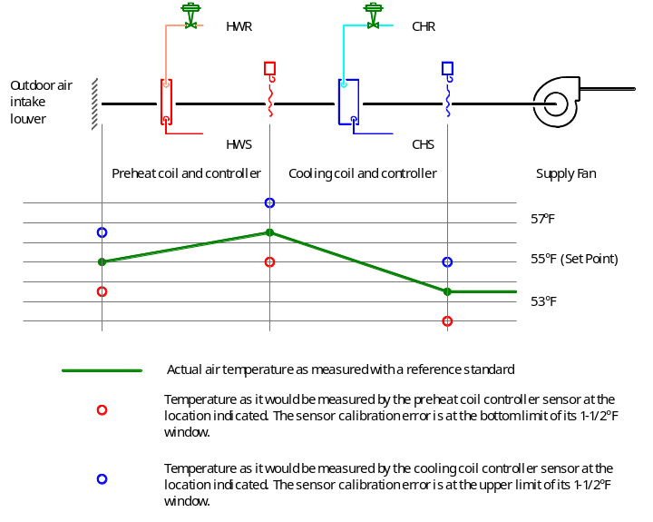
Figure ? - The impact of calibrated accuracy of identical sensors serving the same system and operating at different points with-in their certified calibration accuracy window. This system requires a 55°F cooling coil discharge temperature to satisfy the requirements of the loads it serves. It uses independent control loops for each heat transfer element. All of the sensors serving the system meet the project’s +1.5°F accuracy requirement for averaging type sensors. But, because the one serving the preheat coil is operating at the bottom limit of that range, it detects the outdoor air condition as lower than desired and adds heat, even though this would not be necessary. This air then reaches the cooling coil’s controller which not only re-cools the air to remove the unnecessary heat added by the preheat coil, but actually overcools the air because it is operating at the upper limit of its accuracy window and thus detects the cooling coil leaving condition as being warmer than it actually is. As a result, the AHU uses heating and cooling energy in an unsuccessful attempt to achieve a leaving air temperature that could have been achieved by simply bringing outdoor air into the system at the current condition.
- Via unnecessary heating of the air stream at the coil.
- Via unnecessary heating plant energy to provide the unnecessary heat to the coil.
- Via unnecessary cooling of the air stream to offset the unnecessary heating in order to maintain comfort.
Via unnecessary cooling plant energy to provide the unnecessary cooling to the air stream.
These observations provide insight into the reasoning behind the opening statement of this section. In many instances, the relative accuracy of the sensors in a system is far more important than their absolute accuracy for ensuring efficient performance and detecting problems. Two sensors that are performing per specification but indicating a temperature difference that does not exist could be misleading at best and create operating problems at worst.
Consider a make up air handling system with a preheat coil and cooling coil where each coil is controlled by an independent control loop, a fairly common arrangement. Let’s further assume that the temperature sensors that provide inputs to these control loops are RTDs with flexible averaging elements and 4-20 ma transmitters with an overall accuracy of +1.5°F, a fairly common type of sensor and accuracy for this type of application. It would be possible for this system to perform unnecessary simultaneous heating and cooling, even if both sensors are operating with-in their accuracy window and the set points of the control loops had been coordinated. This is illustrated in Figure ?. Add an economizer to the picture with another independent control loop and the situation could become even worse.
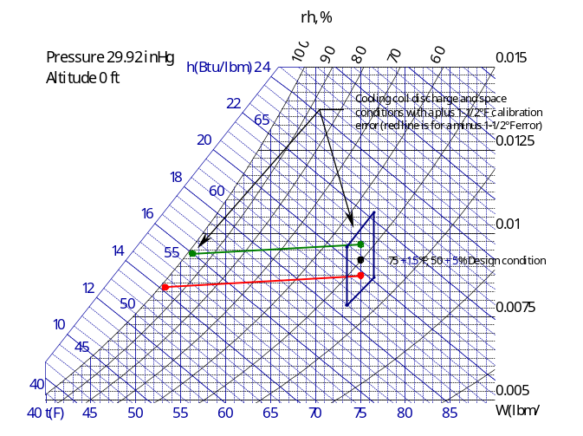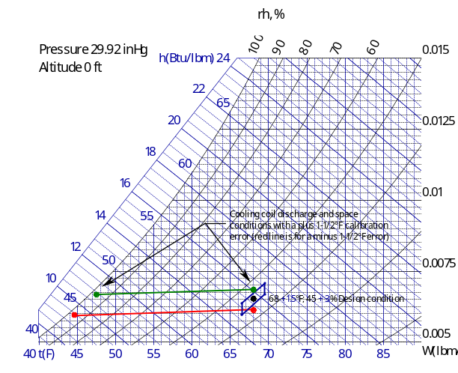
Figure ?? - The impact of cooling coil discharge sensor error on maintaining space conditions inside the design envelope. The psychrometric chart on the left depicts the coil and space conditions that would be associated with a +1-1/2°F calibration error at the sensor controlling the coiling coil discharge temperature in a system serving a clean room. The chart on the right depicts this same situation for an office building comfort cooling application. Notice how the error in measurement at the cooling coil discharge still places the space with-in the design envelope for the comfort cooling process. This same error places the space outside the design envelope for the clean room process.
All of this is not to say that absolute accuracy is not important. For instance, if the discharge temperature of a cooling coil is not controlled accurately in a dehumidification process, then space humidity levels may suffer even though the space temperature is satisfactory. The importance of this will vary with the application as is illustrated in Figure ??. However, even in critical applications like clean rooms, the concern is often not so much for absolute accuracy as it is for stability and repeatability. Absolute accuracy is typically critical in process applications where subjecting the product to a temperature outside of a certain limit will result in unacceptable product or damage. HVAC systems seldom have to deal with this issue directly although they may impact the performance of systems that do.
Some of these issues, such as the absolute sensor accuracy requirements, are best addressed at the time of design. Others, like the relative accuracy of the sensors, can only be addressed under operating conditions, and thus, are best left to the commissioning process where a relative calibration can be performed with the system in operation. In general, a relative calibration test will include the following steps.
1 Identify the sensors in a system where relative accuracy is important in order to ensure efficient operation or proper interpretation of the data the present. Prime candidates include:
- Sensors monitoring temperature, humidity or pressure differentials across equipment.
- Sensors used to calculate energy or mass transfer across a piece of equipment.
- Sensors used in cascaded control loops where the output from one loop becomes the input to another.
2 Identify areas served by the system to be tested and document acceptable deviations from norm that can be tolerated during the time of test.
3 Identify and document any phenomenon like fan heat or duct temperature rise due to transmission that could legitimately change the conditions between the sensors under test.
4 Document the current software calibration and scaling factors and then return them to standard settings so that the information displayed is the actual, un-augmented value from the sensors under test.
5 Place the system in an operating mode that will subject all of the sensors to the same conditions. Often, this involves running the system with the heat transfer elements valved out and/or shut down and at a fixed flow rate.
6 Verify that all sensors are reading with-in their specified accuracy window relative to each other and/or some reference standard.
7 Select a sensor or a reference standard to be the baseline for relative calibration.
8 Identify sensors with calibration errors outside of the certified accuracy range and correct these errors.
9 Adjust software calibration factors as required so that the sensors all read the same value under the test conditions.
10 Document the software calibration factors.
11 Return the system to normal operation.
If time permits and the system can tolerate a longer test window, test the system at a second, different steady state condition with-in the normal operating range prior to returning it to service. For instance, it is often possible to test economizer-equipped units on a mild day so that the test can be performed with full recirculation and on 100% outdoor air, thereby checking the sensors at about 70-75°F and at 50-55°F. This pseudo two-point calibration will help ensure that the final relative calibration factors provide good results under all normal operating conditions. When performed in this manner, it may take several iterations of the test sequence to establish software calibration factors that provide consistent readings among all sensors at both extremes. This can add significantly to the time it takes to run the test and make the adjustments. If time is of the essences or the system and its loads can not tolerate an extended test window or the system typically runs in a very narrow operating range, then satisfactory results can often be obtained by running the test at a condition either in the middle of the normal operating range or at the condition seen most often by the system.
Click on the button below the following table to be taken to a functional test for relative accuracy for the temperature sensors in an air handling unit with an economizer cycle, warm-up coil and cooling coil. The concepts illustrated in this test can be adapted to other system configurations as well as other system types by using the sample as a template for procedures that are specific to your projects.
Background Information
Item | Comments
Purpose of Test | The purpose of the test is to ensure the relative accuracy of a group of sensors associated with a system or selected portion of a system where errors related to the calibration accuracy window of the sensors could cause energy to be wasted or operating data to be misinterpreted.
Instrumentation Required | The fundamental test can be performed without any instrumentation other than the sensors that are being tested. However, a reference standard is helpful to establish the baseline for comparison when making adjustments. Minute by minute trending or data logging of the points under test will be useful to document the test results. A Shortridge meter with a temperature probe makes checking the average mixed air temperature much easier.
Test Conditions | The system needs to be placed in a steady state condition where the parameter measured by the sensors undergoing the relative calibration process can be assumed to be uniform at all points in the portion of the system under test.
Time Required to Test | Test times will vary from 15 minutes to an hour depending on how long it takes to set up for and achieve steady state operation, how many sensors are being calibrated, and the ease of making adjustments.
Acceptance Criteria | 1. With the system in a steady state condition, all sensors read the same value relative to a baseline, with-in their accuracy tolerance prior to adjustment.  2. With the system in a steady state condition, all sensors read the same value after adjustment.
Potential Problems and Cautions | 1. The system will essentially be out of control for the interval of time under which the test occurs. This may or may not be acceptable during occupied hours in the area served, so the test may need to be coordinated to occur when temporary deviations from set point can be tolerated.  2. Absolute sensor calibration should be known to a reasonable degree of certainty. On new construction projects, this can be established fairly easily by the sensor specifications supplemented with a factory calibration certificate. On existing projects, good documentation of periodic calibration checks may prove sufficient. Lacking that it may be desirable to calibrate all sensors to the extent possible in the field. It may be desirable to consider returning critical sensors to a lab or factory for recalibration or replacing them with sensors of known accuracy and then using this sensor as the baseline sensor for the test.  3. Selection of the baseline sensor can be a critical issue. Use of a consistent, reliable baseline standard is the best approach to dealing with issue. Desirable standards include:  - Temperature - Lab grade mercury thermometers with a range and graduations appropriate for the application.  - Humidity or dewpoint - Sling psychrometer and psychrometric chart or ASHRAE psychrometric equations.  - Pressure - Inclined manometer or recently calibrated pressure gauge.  Lacking a standard, the sensor that is most critical to the HVAC process outcome should be selected as the baseline. If all sensors are equally critical to the process, then the sensor that most closely represents the median value indicated by all of the sensors under test should be selected as the baseline.
CTPL Reference | None

Click on the button to go to a sample functional test for relative calibration.
Link to Functional Test RelCal

Return to Overview Table of Contents

Mixed Air Low Limit Test
Energy and Other Benefits
Benefit | Comments
Energy Efficiency Related Benefits
Other Benefits

Click on the button to go to a sample functional test for a mixed air low limit control sequence.
Link to Functional Test MALoLimit

Return to Overview Table of Contents

High Turndown Ratio Test
Energy and Other Benefits
Benefit | Comments
Energy Efficiency Related Benefits
Other Benefits

Background Information
Item | Comments
Purpose of Test
Instrumentation Required
Test Conditions
Time Required to Test
Acceptance Criteria
Potential Problems and Cautions
CTPL Reference

Click on the button to go to a sample functional test for turn down ratio.
Link to Functional Test TurnDown

Return to Overview Table of Contents

Flow Linearity Test
Energy and Other Benefits
Benefit | Comments
Energy Efficiency Related Benefits
Other Benefits

Background Information
Item | Comments
Purpose of Test
Instrumentation Required
Test Conditions
Time Required to Test
Acceptance Criteria
Potential Problems and Cautions
CTPL Reference

Click on the button to go to a sample functional test for flow linearity.
Link to Functional Test LinearFlow

Return to Overview Table of Contents

There are some exceptions, usually in industrial environments. For example, clean rooms often use large recirculating air handling systems to maintain very high air change rates for the purposes of cleanliness. These systems typically have no direct connection with a source of outdoor air but, instead, are supplied with conditioned make-up air from large central make-up air handling systems.
High-rise buildings tend to act like chimneys. In the winter, when the building is generally warmer than the surrounding air, the cold, denser air outside of the building tends to flow into the lower floors of the building via leaks and openings at those levels. This air displaces building air up through the shafts and other vertical openings in the structure and forces it out through cracks and openings at the higher levels. The higher the building and the larger the indoor to outdoor temperature differential, the more pronounced this effect will be. In the summer, this flow pattern reverses itself when the air outside is warmer than the air inside. One of the implications of this phenomenon is that there are pressure differences between the interior of the building and the surrounding environment and that these differences will vary from negative to positive over the height of the structure. The point where the pressure inside and outside is identical is called the neutral plane. The elevation of the neutral plane will shift up and down the building as a function of outdoor and indoor temperature, exhaust flow rate and make up flow rate.
With out such regulation, variations in the system pressure relationships that occur with variations in flow on VAV systems can change the minimum outdoor air percentage as the sensible load changes. This may or may not be desirable depending on the relationship between occupancy and sensible loads. If the sensible load is closely coupled to occupancy, then it is desirable to reduce the minimum outdoor air flow rate as the system flow rate drops off, which tends to maintain a constant percentage of minimum outdoor air. Without regulation, many systems will tend to maintain a constant minimum outdoor air flow rate which increases the minimum outdoor air percentage at low flow. This situation can cause a system to preheat when it is unnecessary.
Auditoriums and theaters are good examples of this operating condition. These areas typically house a large number of people, thus requiring a very high ventilation rate. But, since the lights are often at low settings or off and there are not equipment loads except on in the area of the stage, the net cooling load on the space is low and the systems approach 100% outdoor air operation to meet the ventilation load as the internal heat loads drop off, assuming that there is some control strategy in place to regulate the minimum outdoor air flow rate. In this type of system, preheat may be unavoidable due to the high percentage of minimum outdoor air required with low sensible gains in the space.
This has some other advantages since it is often better to have a small actuator on each section rather than a large actuator with a jackshaft running multiple sections to ensure that the dampers achieve their leakage rating.
See 1999 NFPA 90A paragraph 2-3.9.2 for and example of this requirement. Other codes contain similar language or simply refer to NFPA.
For instance, the temperature associated with saturated low pressure steam can often be in the 240°F range. Air in the vicinity of a steam coil with the control valve wide open and no air flow will approach this temperature.
Since the return fan will pressurize the mixing plenum in this operating mode, it is likely that air will be blowing backwards (out) of the intake louver. Since this means air is leaving the building at the intake louver, then air must be entering the building at some other location, probably through leakage around cracks or through other air handling systems. Eventually, this could cause freezing problems at those locations.
Centrifugal fans will generate their rated pressure on their inlet or their outlet or both. If the inlet connection is totally closed off, as would occur if a control failure caused both the outdoor air and return air dampers to close, then the fan will generate its rated no-flow static pressure as a negative pressure on the inlet side since the discharge is essentially referenced to atmospheric pressure. via the supply duct system. If this no-flow or shut off static pressure rating exceeds the negative pressure class of the intake duct or the negative pressure rating of the air handling unit casing, the casing or duct could collapse. Note that the positive and negative pressure ratings for any given duct construction is usually not the same. Typically a duct will be capable of withstanding more positive pressure than negative pressure.
While not the standard configuration for most systems, this arrangement will often be found on systems where the return damper provides the smoke isolation function required by NFPA or other building codes and in systems with parallel air handling units where the return damper is used to isolate the off-line system from the ductwork and other operating systems to prevent backflow.
Enthalpy sensors tend to require more attention than temperature sensors if they are to remain reliable. This is discussed in greater detail later in this chapter under Sensing Elements.
To gain some insight into this, consider two parallel blade dampers, one sized for an α = 10 and the other sized for an α = 200. By looking at the curves in Figure 5.?, it can be seen that when the first damper is at 20% stroke, the flow through it will be approximately 28% of maximum. While not perfectly linear, this control is much better than the second damper, which at 20% stroke allows nearly 77% of maximum flow. The over-sizing of the damper causes the controller to have to control over a limited portion of its span, making it difficult to achieve tight, stable control.
This sequence would be typically be overridden when outdoor conditions were no longer suitable for free cooling to return the system to minimum outdoor air.
See the Ductwork and Accessories section of Chapter 6 - Outdoor Air Intake Section for a discussion of air hammer and its effects.
Note that there still may be a maximum allowable actuation time for life safety related functions like smoke or fire dampers that is dictated by the governing codes.
Some manufacturers have developed devices that combine an electronic to pneumatic signal converter in the same package as a pneumatic positioning relay.
Mass flow rate will in fact influence the sensed temperature to some extent in that higher mass flow rates will have better convective heat transfer coefficients between the sensing element and the air stream. Sensing elements in air streams with higher mass flow rates (and thus higher velocities) will generally display a quicker response to a change and a closer approach to the actual air stream temperature. These effects are relatively insignificant in the context of the accuracy of the temperature measurements made in a mixed air plenum. The improved response characteristic associated with the higher flow rates can make the control loop easier to tune because time lags are reduced.
Four inches in diameter is a fairly typical size for many of the pneumatic pressure transmitters in the commercial market. One tenth of an inch water column is probably the high end of the control range for building static pressure; i.e. you will control for that pressure or less and need to be able to detect and respond to changes that are at least one order of magnitude smaller (one one hundredth of an inch water column).
Hot wire anemometers and other thermally based flow measuring technologies are very sensitive to low flow rates. They work by measuring the cooling effect of airflow over a heated wire. The amount of cooling is directly related to velocity and thus to flow. By measuring the energy used to heat the wire, the devices can detect and accurately report very low flow rates.
There are commercially available products that perform this function, but one can be easily fabricated in the field from a 6” long piece of 1/2” or 3/4” PVC pipe, a couple of end caps, an in line pneumatic control system restrictor fitting, a barbed fitting. and some 10 minute epoxy. Since the pressures are in terms of inches w.c., the pressure rating of the assembly is not critical. The caps are simply glued to the end of the tube and drilled to accommodate the inline restrictor fitting at one end and the barbed fitting at the other. The fittings are then epoxied in place. The pulsation chamber is then simply installed in the line ahead of the transmitter.
See Chapter 5.21 - Integrated Control Functions for information regarding how these optimization routines are applied and integrated into the overall air handling system functionality and for tests targeted at verifying their performance.
For the purposes of our discussion, relative accuracy is defined as the accuracy of the sensors relative to each other and perhaps some field reference standard. Absolute accuracy is the accuracy of the sensor relative to a NBS traceable standard.
The symbol “+” should be read as “plus or minus” indicating that the true value will be the indicated value “plus or minus” the accuracy tolerance.
The window in which the true temperature lies is equal to twice the temperature sensor’s accuracy range centered on the indicated value. In our example, if the sensor were reading 1.5°F low, then the true temperature would be 1.5°F higher than the indicated temperature. On the other hand, if the sensor were reading 1.5°F high, then the true temperature would be 1.5°F lower than the indicated temperature. Since we don’t know if the sensor is reading high or low, just that it is capable of reading +1.5°F of the true temperature, then we can only assume that the temperature is with-in this window created by the sensor’s accuracy tolerance.
This would occur if one sensor were reading at the high end of its accuracy tolerance and the other sensor were reading at the low end of its accuracy tolerance.
This can be a direct or indirect process. For instance, many cooling coils are controlled for a fixed leaving air temperature to guarantee that the air leaving them will provide adequate dehumidification as well as sensible cooling for the spaces they serve. This in effect, forces a temperature difference (and the desired energy transfer) to occur at the coil for operating conditions where the entering air is warmer than the leaving air.
For example in clean rooms, the issue often is not the exact temperature and humidity in the space but the stability of these parameters and the consistency of the documentation of them. If the space can be maintained at a consistent, steady temperature and humidity, then the accuracy and calibration of sensitive inspection and assembly equipment used in the process can be ensured. Often, the calibration and alignment of these machines is quite sensitive to changes in the environment, so as long as the environment remains stable at the condition at which the machine was aligned and calibrated, then the process can be relied upon to produce good product. In order to document that the product is in fact going to meet specs, the quality control staff often wants to document that the clean room environment was stable, thus implying that alignment and calibration of the machinery was not affected by changes in the environment. Thus, the repeatability of the readings taken becomes important.
The system will be essentially out of control for the duration of the test. In many cases, this will not be a significant problem since the test will not last that long and/or the test condition can be selected to minimize the disruption to the loads. However, there may be critical zones on the system, like a lab or a computer room, which can not tolerate a significant disruption. This may mean that the test will need to be coordinated to occur when a disruption can be tolerated. It may also mean that it is necessary to trend the space during the test to document any deviations from norm that occur.
If the test is to include the return air temperature sensor on an economizer equipped unit, then the best test will result if the system is operated in full recirculation with no minimum outdoor air or exhaust since this virtually eliminates one variable from the system (the temperature change associated with mixing the minimum outdoor air with the return air). This may or may not be possible depending on the nature of the loads in the building and the time when the test is scheduled to occur. If it is not possible, then it will be necessary to document the temperature change associated with the mixing function or simply eliminate the return sensor from the test. Poor mixing can also be a problem for sensors located immediately down stream of the mixing box if the test is performed in any mode other than 100% outdoor air or 100% recirculation. If the system has leaky dampers, then some temperature change may occur through the mixing plenum even with no outdoor air being introduced actively. An effort should be made to document this if possible. Testing on mild days so that any minor leakage that does occur will have a minimum impact on the temperature in the system can mitigate the effect. Similar considerations apply when testing humidity sensors located at various points in the system.
For example, if the sensor you are testing is a 4-20 ma sensor with a range of 0-100°F, then set the system up so that 4ma indicates 0°F and 20ma indicates 100°F. You may discover that the system is already set up to do this. However, it is not uncommon to adjust the software scaling and calibration factors to “tweak” a sensor reading and compensate for its certified accuracy limitations so that it reads closer to the true temperature. In fact, this is exactly what we will do later in the procedure to calibrate the sensors relative to each other. But, at this stage of the test, it is important that the system be set up to the sensor standards to allow a baseline to be established and evaluate if everything is reading with-in its certified accuracy specification.
The more positive the elimination of the potential for heat transfer is, the better. For instance, forcing the control valve to a hot water coil closed is the bare minimum requirement. Forcing the valve closed and manually closing both service valves is better. Shutting down the hot water system is best. It is also important to deal with passive elements like preheat coils with face and bypass dampers and humidifier manifolds to eliminate their impact. Even if a preheat coil is in full bypass, there can still be heat transfer via radiation and leakage from the heating element, so it needs to be shut down for the test. Even if a humidifier is not active, its jacket heating system is and will add several degrees of temperature rise to the system, thus it needs to be shut down for the test.
If the parameter is truly critical to the process, a regular program of certifiable calibration should be implemented. There are several approaches t hat can be used for this including true multipoint calibration in the field if the necessary constant temperature baths, current and voltage simulators, decade boxes, etc. are available. A more practical alternative for Owners who do not have access to an instrument shop and/or instrumentation engineers may be to maintain a spare sensor in stock that can be calibrated and switched periodically with the operating sensor. The sensor that was in service can then be sent out for factory calibration, returned to stock, and then used for the swap at the next calibration cycle.

